UNITED STATES
SECURITIES AND EXCHANGE COMMISSION
WASHINGTON, D.C. 20549

FORM 8-K

CURRENT REPORT
PURSUANT TO SECTION 13 OR 15(d)
OF THE SECURITIES EXCHANGE ACT OF 1934

Date of Report (Date of earliest event reported): October 6, 2026

60 DEGREES PHARMACEUTICALS, INC.
(Exact name of registrant as specified in its charter)

Delaware |  | 001-41719 |  | 45-2406880
(State or other jurisdiction  of Incorporation) |  | (Commission File Number) |  | (IRS Employer  Identification Number)

1025 Connecticut Avenue NW Suite 1000,  Washington, D.C. |  | 20036
(Address of registrant’s principal executive office) |  | (Zip code)

(202) 327-5422
(Registrant’s telephone number, including area code)

Not Applicable
(Former name or former address, if changed since last report)

Check the appropriate box below if the Form 8-K filing is intended to simultaneously satisfy the filing obligation of the registrant under any of the following provisions (see General Instruction A.2. below):

☐ | Written communications pursuant to Rule 425 under the Securities Act (17 CFR 230.425)

☐ | Soliciting material pursuant to Rule 14a-12 under the Exchange Act (17 CFR 240.14a-12)

☐ | Pre-commencement communications pursuant to Rule 14d-2(b) under the Exchange Act (17 CFR 240.14d-2(b))

☐ | Pre-commencement communications pursuant to Rule 13e-4(c) under the Exchange Act (17 CFR 240.13e-4(c))

Securities registered pursuant to Section 12(b) of the Act:

Title of each class |  | Trading symbol(s) |  | Name of each exchange on which registered
Common Stock, par value $0.0001 per share |  | SXTP |  | The Nasdaq Stock Market LLC
Warrants, each warrant to purchase one share of Common Stock |  | SXTPW |  | The Nasdaq Stock Market LLC

Indicate by check mark whether the registrant is an emerging growth company as defined in Rule 405 of the Securities Act of 1933 (§230.405 of this chapter) or Rule 12b-2 of the Securities Exchange Act of 1934 (§240.12b-2 of this chapter).

Emerging growth company ☒

If an emerging growth company, indicate by check mark if the registrant has elected not to use the extended transition period for complying with any new or revised financial accounting standards provided pursuant to Section 13(a) of the Exchange Act. ☐

Item 7.01 Regulation FD Disclosure

On October 6, 2026, the Company updated its investor presentation, which it intends to use from time to time in meetings with investors, analysts and other members of the investment community. A copy of the updated investor presentation is furnished as Exhibit 99.1 to this Current Report on Form 8-K and is incorporated herein by reference.

The information furnished pursuant to this Item 7.01, including Exhibit 99.1, shall not be deemed “filed” for purposes of Section 18 of the Securities Exchange Act of 1934, as amended, or otherwise subject to the liabilities of that section, nor shall it be deemed incorporated by reference into any filing under the Securities Act of 1933, as amended, or the Securities Exchange Act of 1934, as amended, except as expressly set forth by specific reference in such filing.

Cautionary Statement Regarding Forward-Looking Statements

This Current Report on Form 8-K includes forward-looking statements within the meaning of the Private Securities Litigation Reform Act of 1995. Such statements involve risks and uncertainties that could cause the Company’s actual results and financial position to differ materially. These risks and uncertainties include uncertainties associated with market conditions and other risks described under the heading “Risk Factors” in the Company’s SEC Filings on Form 10-K and Form 10-Q. The Company assumes no responsibility to update or revise any forward-looking statements to reflect events, trends or circumstances after the date hereof.

Item 8.01 Other Events.

On October 6, 2026, the Company issued a press release announcing an update to its January 2027 hospitalized babesiosis data readout. The full text of the press release is attached as Exhibit 99.2 to this Current Report on Form 8-K and incorporated herein by reference.

Item 9.01 Financial Statements and Exhibits

(a) Exhibits

Number |  | Description
99.1 |  | 60 Degrees Pharmaceuticals, Inc. Investor Presentation, dated October 6, 2026
99.2 |  | Press Release dated October 6, 2026
104 |  | Cover Page Interactive Data File (embedded within the Inline XBRL document)

1

SIGNATURES

Pursuant to the requirements of the Securities Exchange Act of 1934, the registrant has duly caused this report to be signed on its behalf by the undersigned hereunto duly authorized.

 | 60 DEGREES PHARMACEUTICALS, INC.
Date: October 6, 2026 | By: | /s/ Geoffrey Dow
 | Name: | Geoffrey Dow
 | Title: | Chief Executive Officer and President

2

Exhibit 99.1

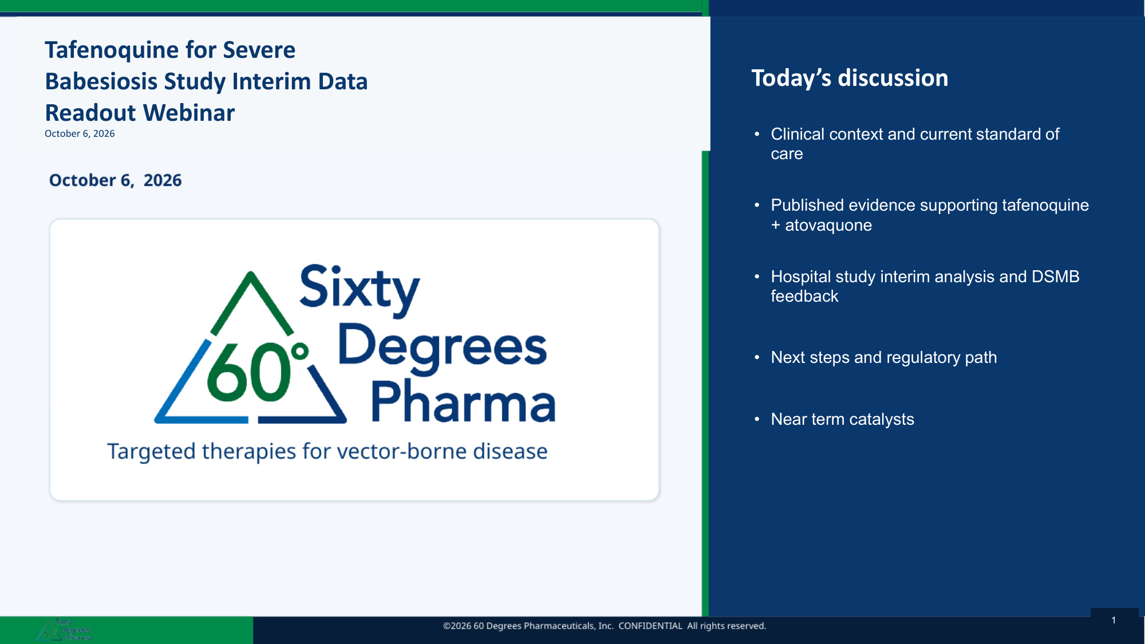
Tafenoquine for Severe Babesiosis Study Interim Data Readout Webinar October 6, 2026 Today's discussion • Clinical context and current standard of care • Published evidence supporting tafenoquine + atovaquone • Hospital study interim analysis and DSMB feedback • Next steps and regulatory path • Near term catalysts 1

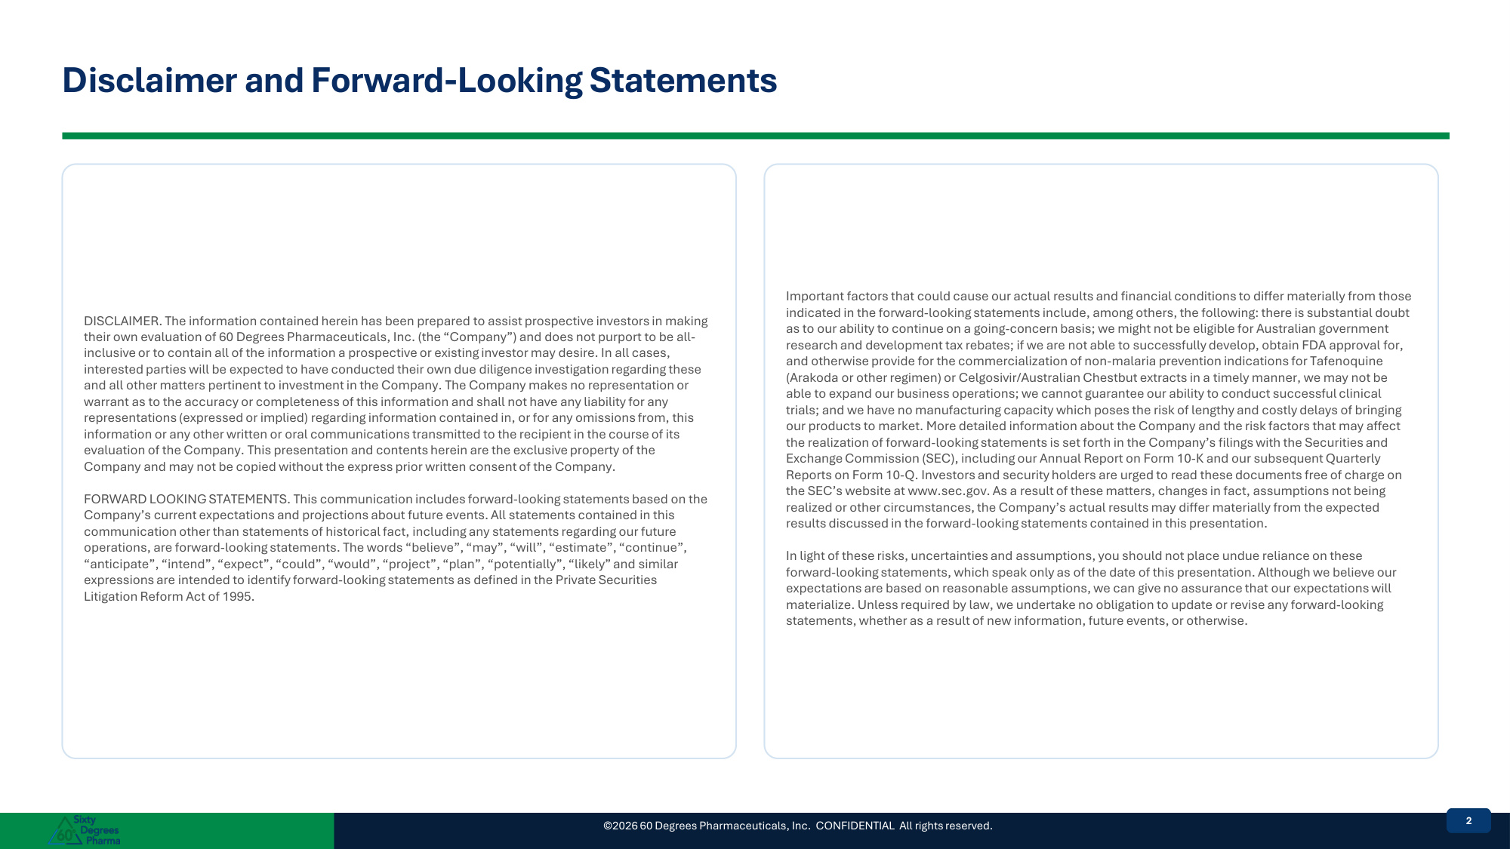
Disclaimer and Forward-Looking Statements DISCLAIMER. The information contained herein has been prepared to assist prospective investors in making their own evaluation of 60 Degrees Pharmaceuticals, Inc. (the "Company") and does not purport to be all- inclusive or to contain all of the information a prospective or existing investor may desire. In all cases, interested parties will be expected to have conducted their own due diligence investigation regarding these and all other matters pertinent to investment in the Company. The Company makes no representation or warrant as to the accuracy or completeness of this information and shall not have any liability for any representations (expressed or implied) regarding information contained in, or for any omissions from, this information or any other written or oral communications transmitted to the recipient in the course of its evaluation of the Company. This presentation and contents herein are the exclusive property of the Company and may not be copied without the express prior written consent of the Company. FORWARD LOOKING STATEMENTS. This communication includes forward-looking statements based on the Company's current expectations and projections about future events. All statements contained in this communication other than statements of historical fact, including any statements regarding our future operations, are forward-looking statements. The words "believe", "may", "will", "estimate", "continue", "anticipate", "intend", "expect", "could", "would", "project", "plan", "potentially", "likely" and similar expressions are intended to identify forward-looking statements as defined in the Private Securities Litigation Reform Act of 1995. Important factors that could cause our actual results and financial conditions to differ materially from those indicated in the forward-looking statements include, among others, the following: there is substantial doubt as to our ability to continue on a going-concern basis; we might not be eligible for Australian government research and development tax rebates; if we are not able to successfully develop, obtain FDA approval for, and otherwise provide for the commercialization of non-malaria prevention indications for Tafenoquine (Arakoda or other regimen) or Celgosivir/Australian Chestbut extracts in a timely manner, we may not be able to expand our business operations; we cannot guarantee our ability to conduct successful clinical trials; and we have no manufacturing capacity which poses the risk of lengthy and costly delays of bringing our products to market. More detailed information about the Company and the risk factors that may affect the realization of forward-looking statements is set forth in the Company's filings with the Securities and Exchange Commission (SEC), including our Annual Report on Form 10-K and our subsequent Quarterly Reports on Form 10-Q. Investors and security holders are urged to read these documents free of charge on the SEC's website at www.sec.gov. As a result of these matters, changes in fact, assumptions not being realized or other circumstances, the Company's actual results may differ materially from the expected results discussed in the forward-looking statements contained in this presentation. In light of these risks, uncertainties and assumptions, you should not place undue reliance on these forward-looking statements, which speak only as of the date of this presentation. Although we believe our expectations are based on reasonable assumptions, we can give no assurance that our expectations will materialize. Unless required by law, we undertake no obligation to update or revise any forward-looking statements, whether as a result of new information, future events, or otherwise. ©2026 60 Degrees Pharmaceuticals, Inc. CONFIDENTIAL All rights reserved. 22

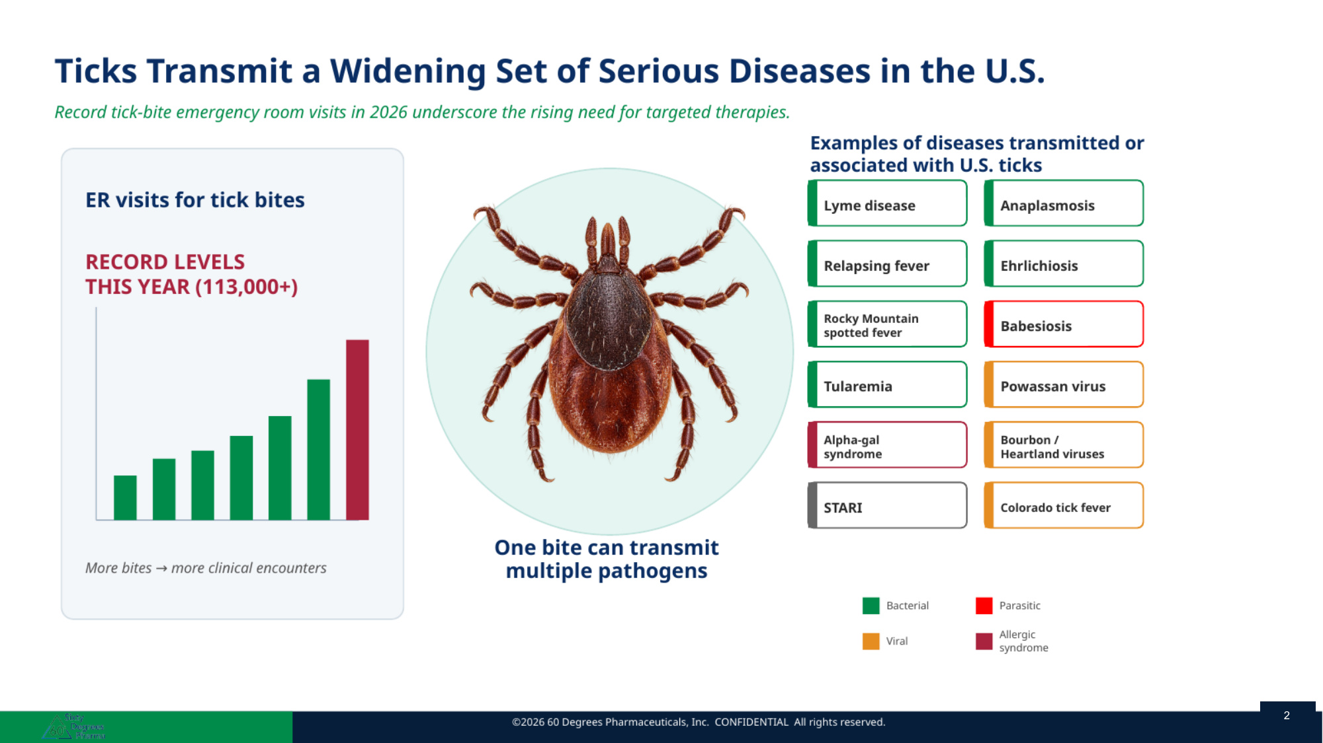
2

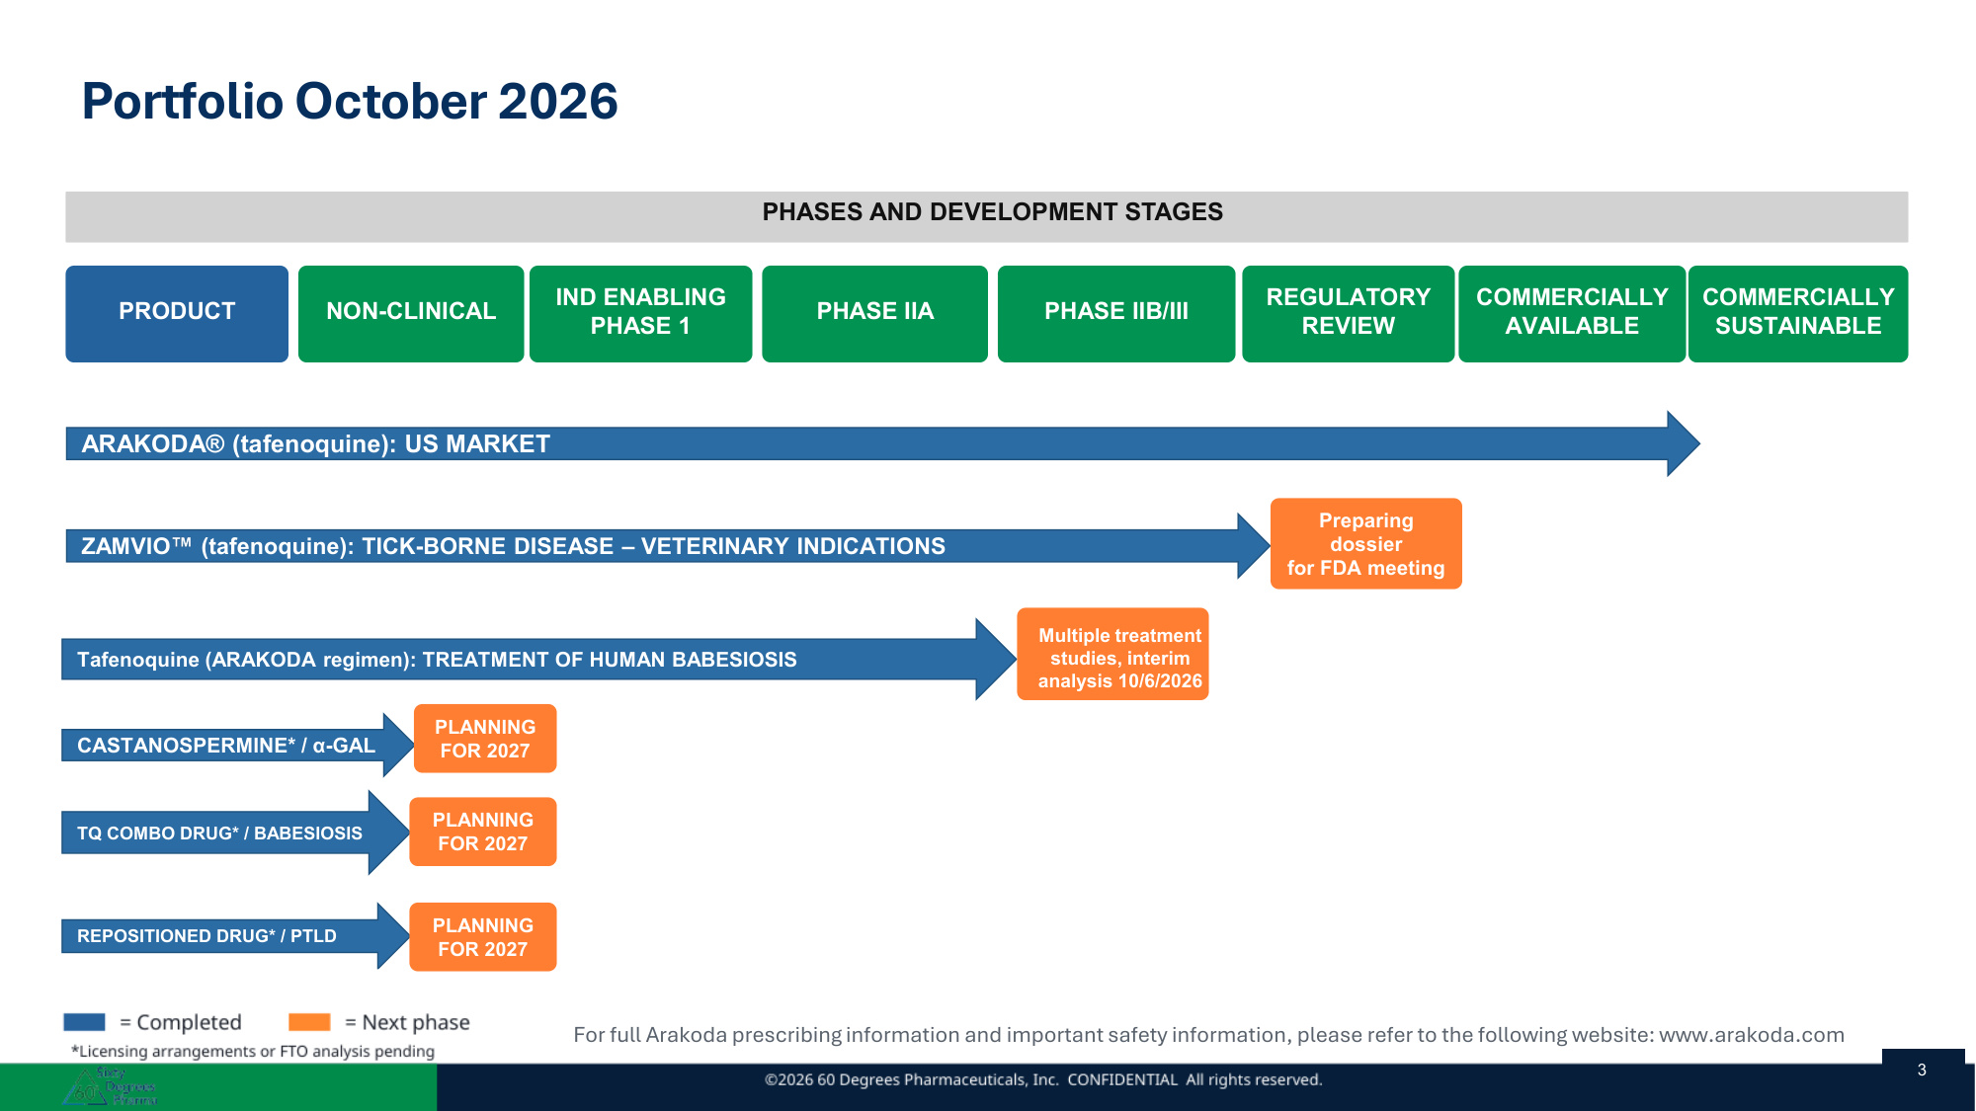
PHASES AND DEVELOPMENT STAGES PRODUCT NON-CLINICAL IND ENABLING PHASE 1 PHASE IIA PHASE IIB/III REGULATORY REVIEW COMMERCIALLY AVAILABLE COMMERCIALLY SUSTAINABLE ARAKODA® (tafenoquine): US MARKET ZAMVIO (tafenoquine): TICK-BORNE DISEASE – VETERINARY INDICATIONS Tafenoquine (ARAKODA regimen): TREATMENT OF HUMAN BABESIOSIS CASTANOSPERMINE* / α-GAL TQ COMBO DRUG* / BABESIOSIS REPOSITIONED DRUG* / PTLD Preparing dossier for FDA meeting Multiple treatment studies, interim analysis 10/6/2026 PLANNING FOR 2027 PLANNING FOR 2027 PLANNING FOR 2027 Portfolio October 2026 For full Arakoda prescribing information and important safety information, please refer to the following website: www.arakoda.com 3

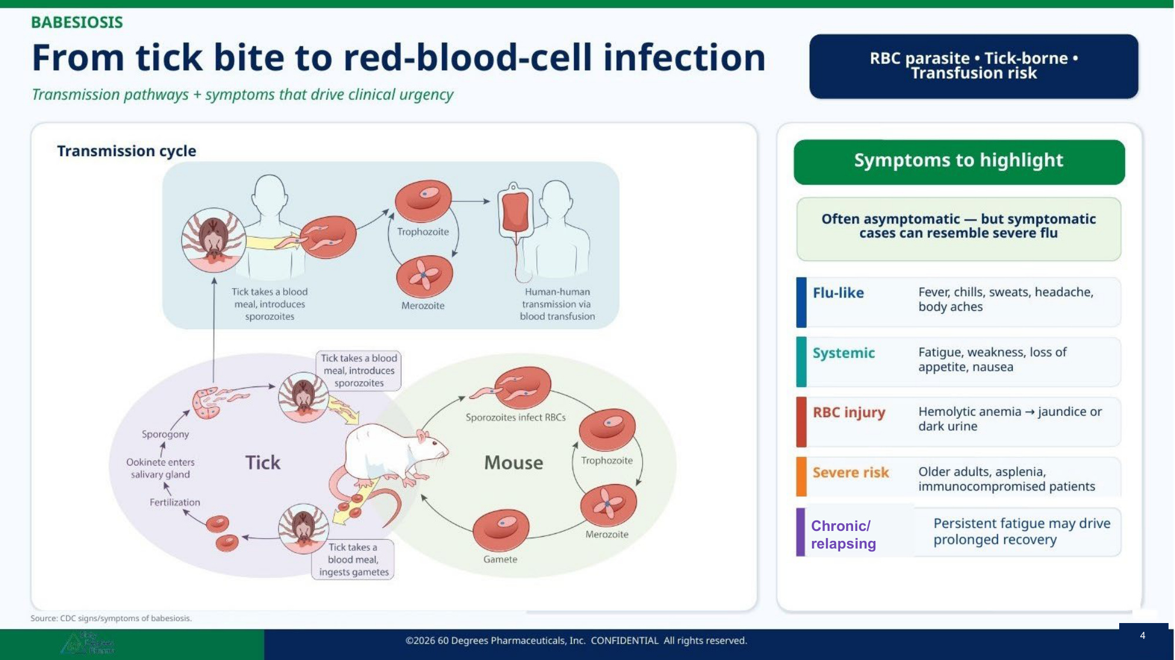
Chronic/ relapsing 4

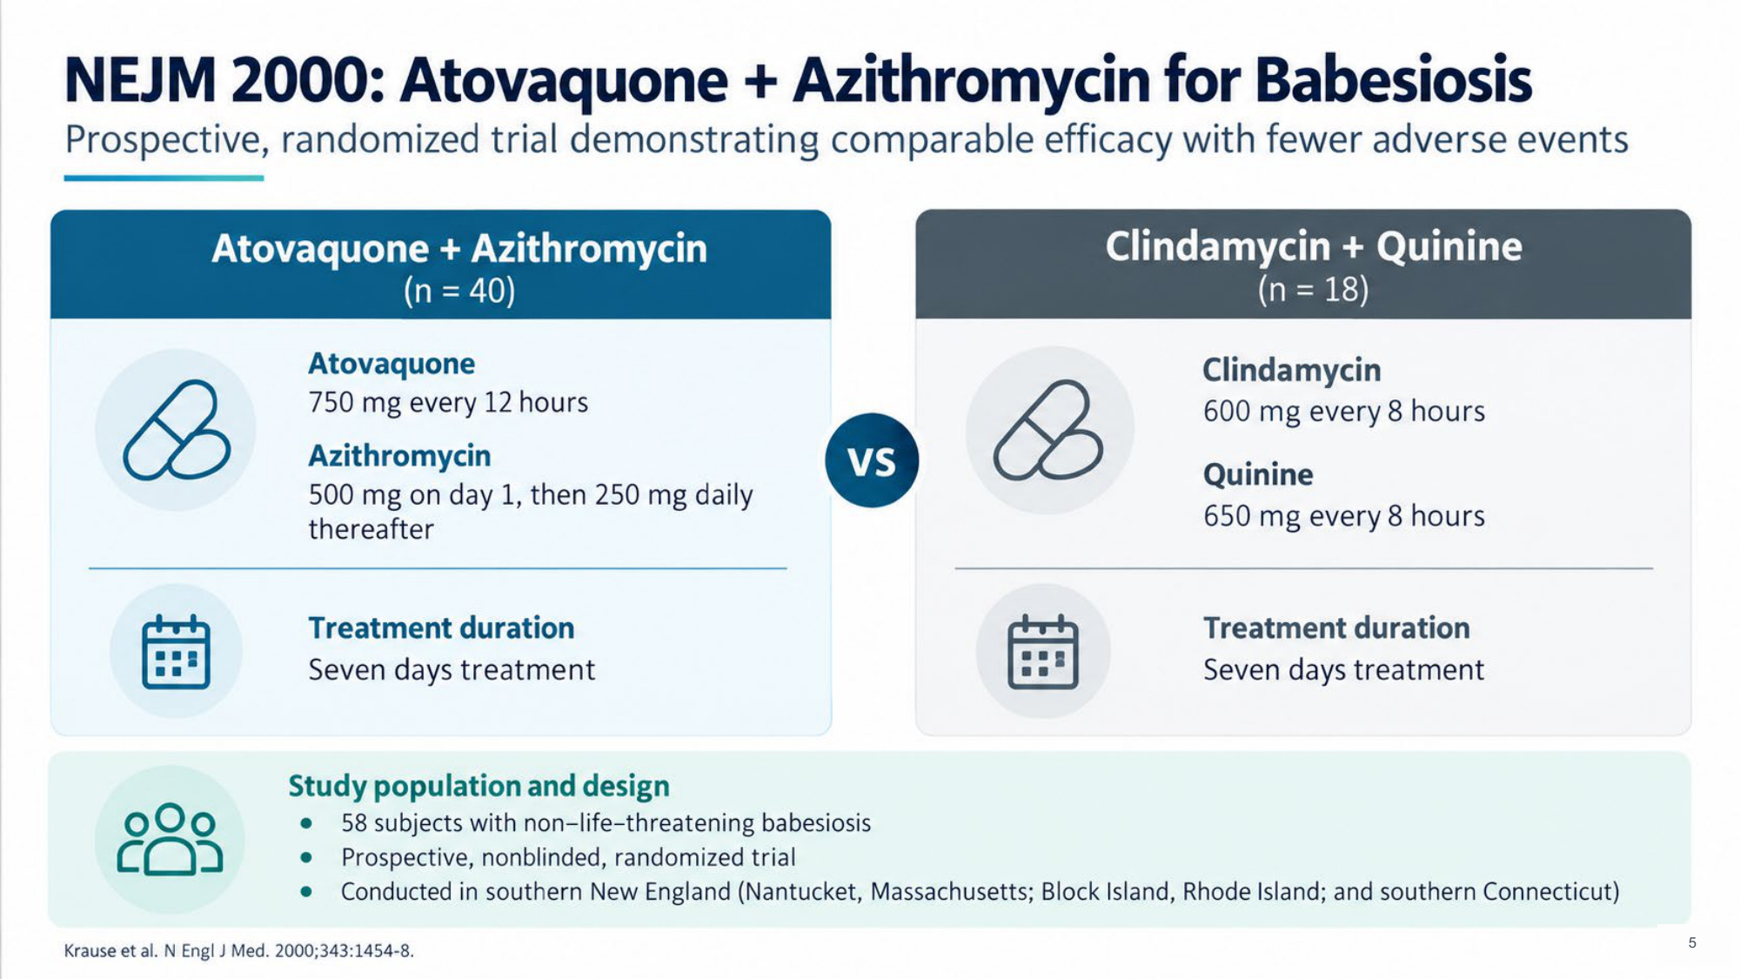
5

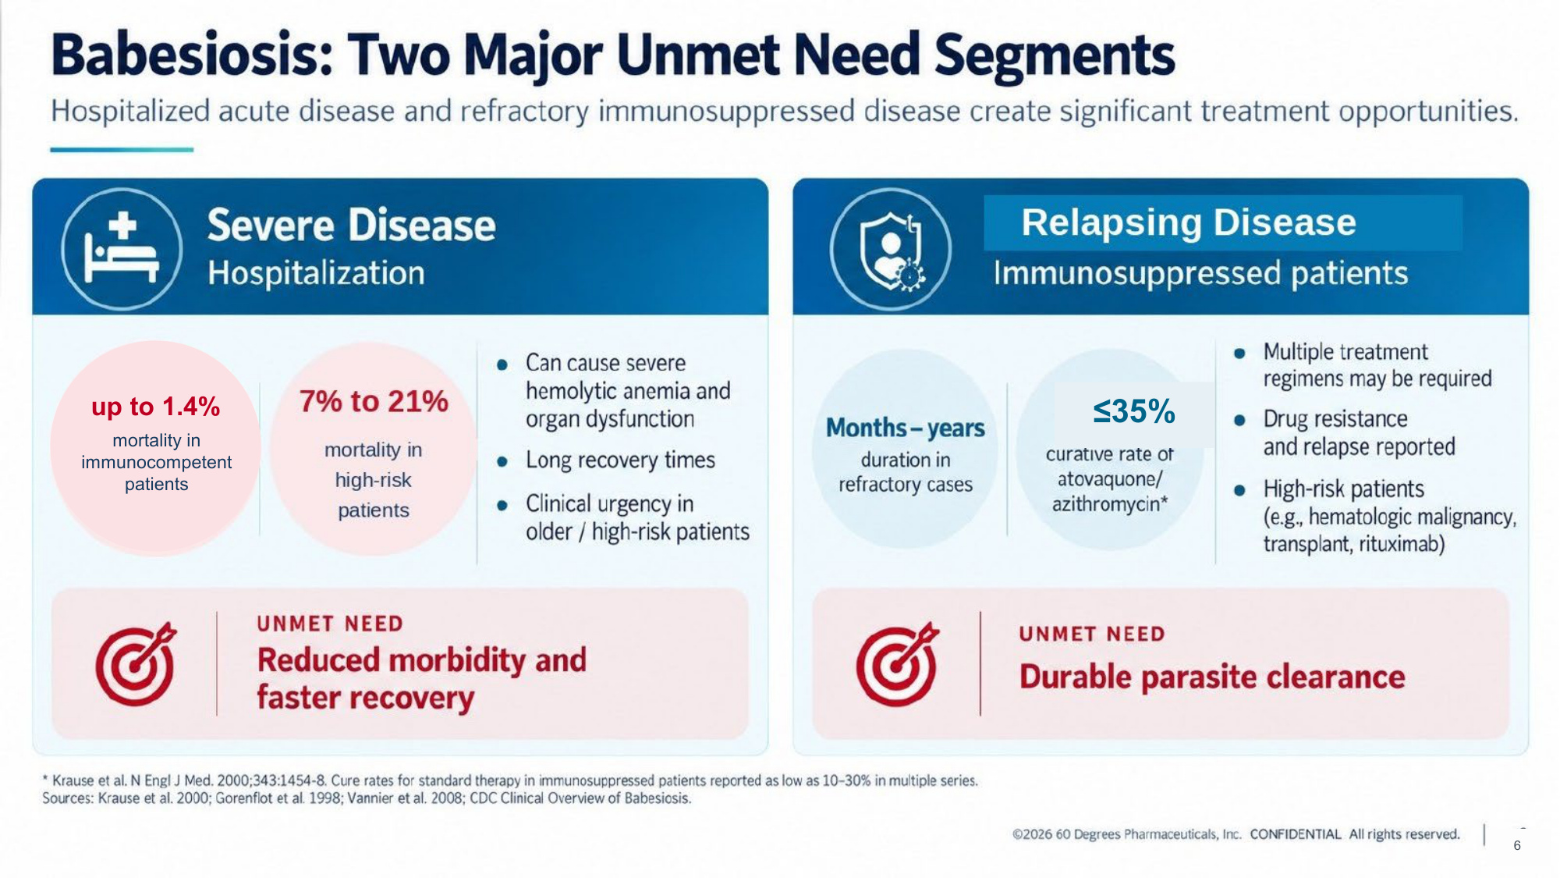
≤35% up to 1.4% mortality in immunocompetent patients 6

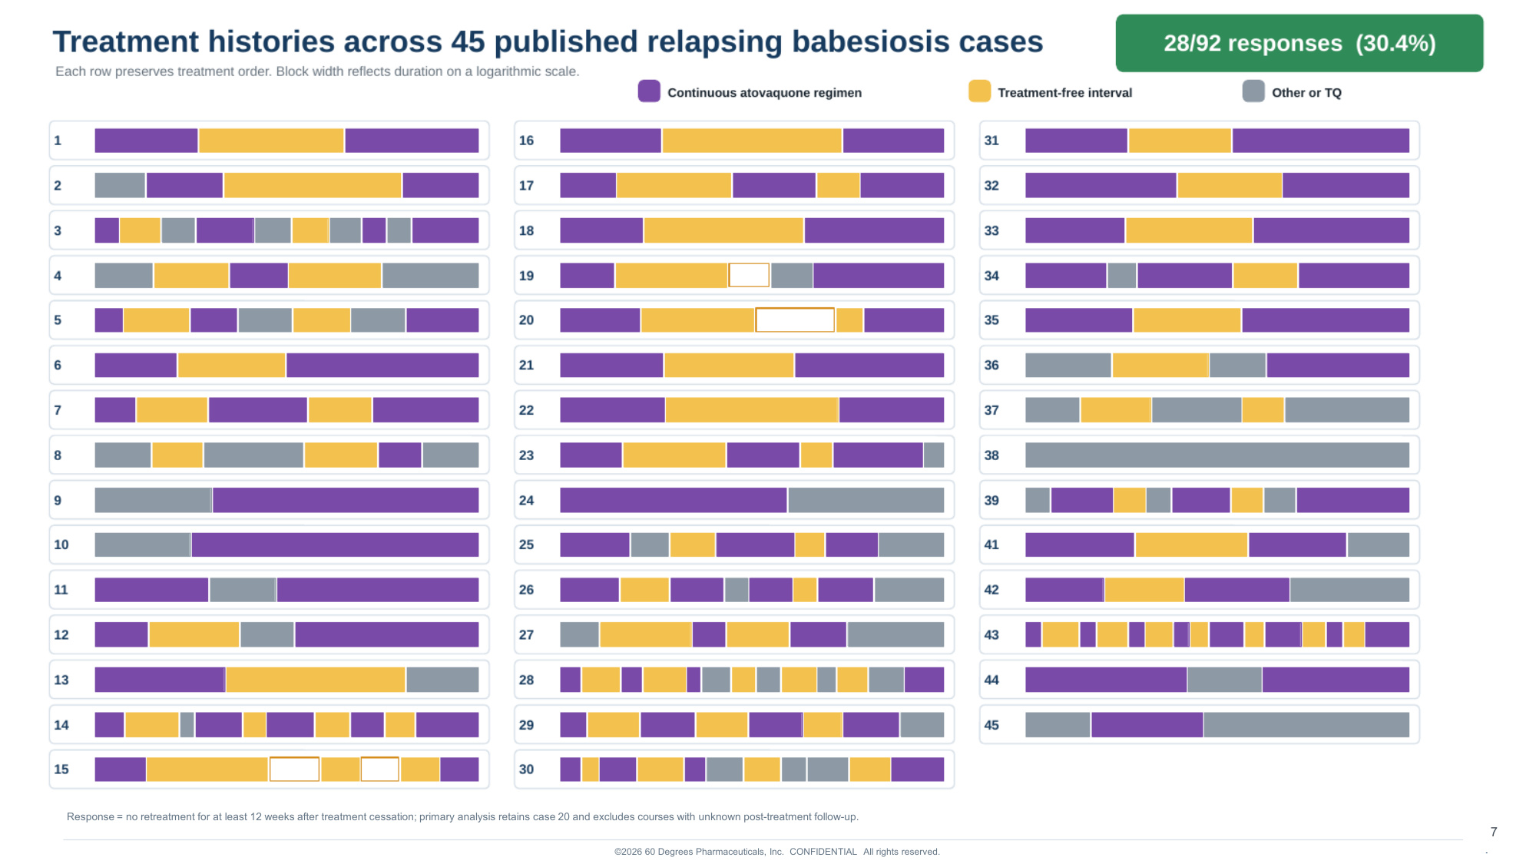
Response = no retreatment for at least 12 weeks after treatment cessation; primary analysis retains case 20 and excludes courses with unknown post-treatment follow-up. ©2026 60 Degrees Pharmaceuticals, Inc. CONFIDENTIAL All rights reserved. 7 7

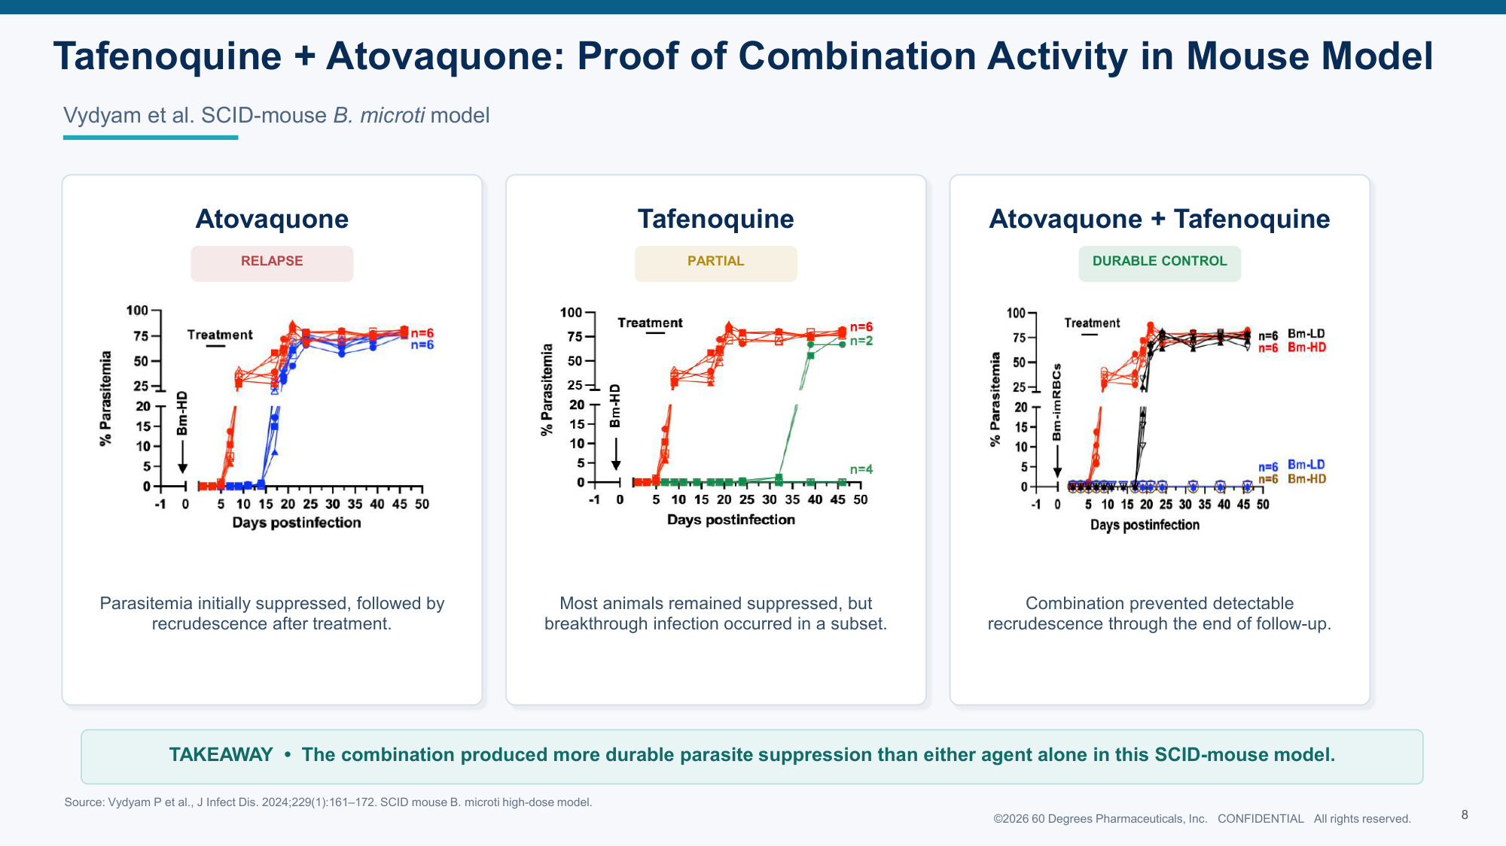
©2026 60 Degrees Pharmaceuticals, Inc. CONFIDENTIAL All rights reserved. 8 Tafenoquine + Atovaquone: Proof of Combination Activity in Mouse Model Vydyam et al. SCID-mouse B. microti model Atovaquone RELAPSE Parasitemia initially suppressed, followed by recrudescence after treatment. Tafenoquine PARTIAL Most animals remained suppressed, but breakthrough infection occurred in a subset. Atovaquone + Tafenoquine DURABLE CONTROL Combination prevented detectable recrudescence through the end of follow-up. TAKEAWAY • The combination produced more durable parasite suppression than either agent alone in this SCID-mouse model. Source: Vydyam P et al., J Infect Dis. 2024;229(1):161–172. SCID mouse B. microti high-dose model. 8

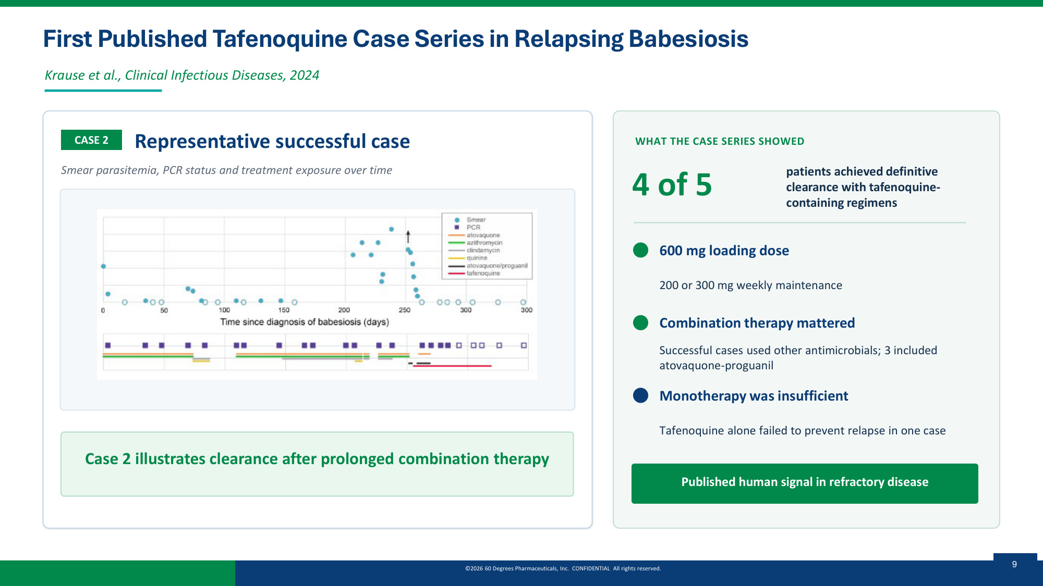
First Published Tafenoquine Case Series in Relapsing Babesiosis Krause et al., Clinical Infectious Diseases, 2024 CASE 2 Representative successful case Smear parasitemia, PCR status and treatment exposure over time Case 2 illustrates clearance after prolonged combination therapy WHAT THE CASE SERIES SHOWED 4 of 5 patients achieved definitive clearance with tafenoquine- containing regimens 600 mg loading dose 200 or 300 mg weekly maintenance Combination therapy mattered Successful cases used other antimicrobials; 3 included atovaquone-proguanil Monotherapy was insufficient Tafenoquine alone failed to prevent relapse in one case Published human signal in refractory disease ©2026 60 Degrees Pharmaceuticals, Inc. CONFIDENTIAL All rights reserved. 99

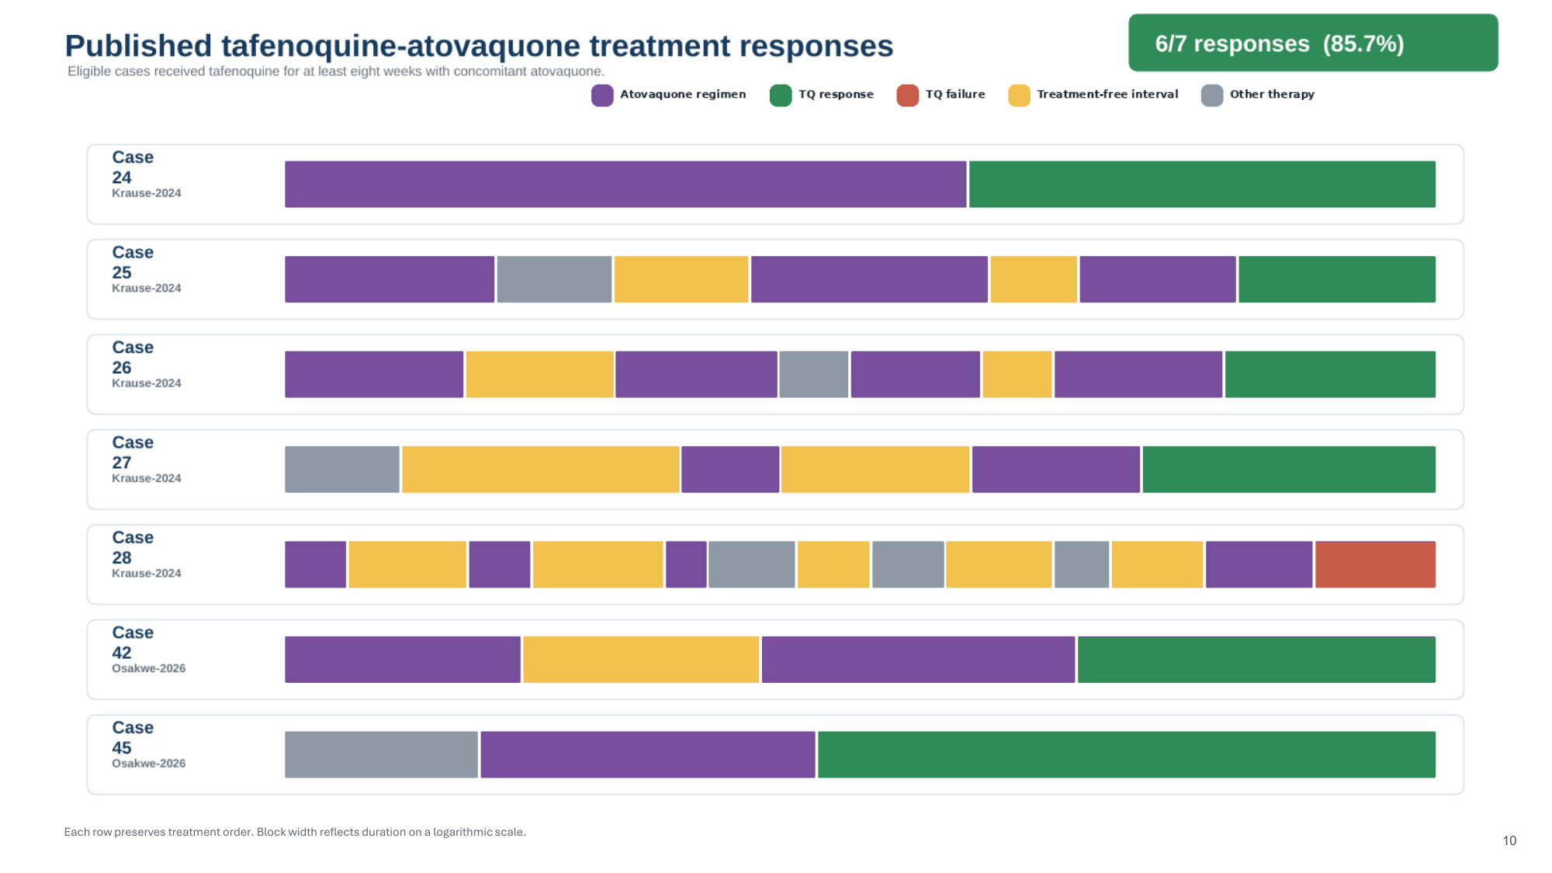
Each row preserves treatment order. Block width reflects duration on a logarithmic scale. 10

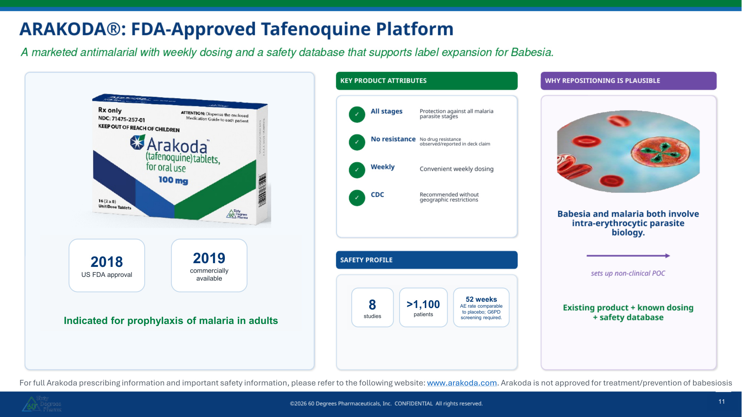
11 adult age group indicated 11 11 11 2018 US FDA approval 2019 commercially available Indicated for prophylaxis of malaria in adults 8 studies >1,100 patients 52 weeks AE rate comparable to placebo; G6PD screening required. For full Arakoda prescribing information and important safety information, please refer to the following website: www.arakoda.com. Arakoda is not approved for treatment/prevention of babesiosis 11

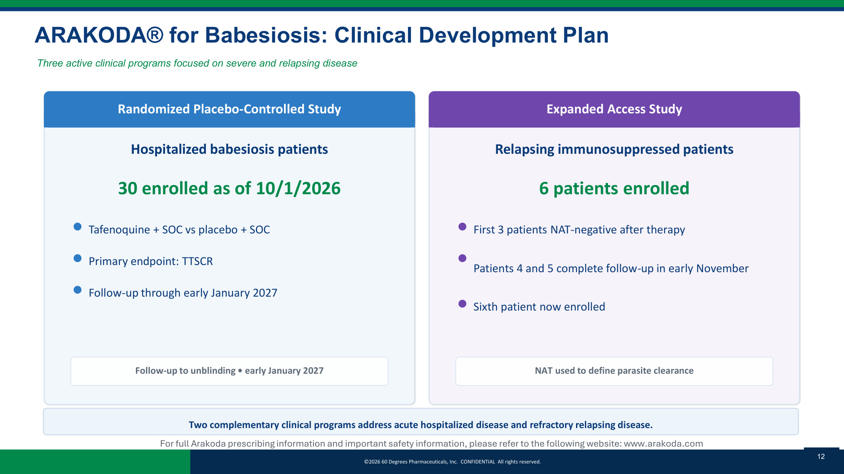
ARAKODA® for Babesiosis: Clinical Development Plan Three active clinical programs focused on severe and relapsing disease Randomized Placebo-Controlled Study Hospitalized babesiosis patients 30 enrolled as of 10/1/2026 Tafenoquine + SOC vs placebo + SOC Primary endpoint: TTSCR Follow-up through early January 2027 Follow-up to unblinding • early January 2027 Expanded Access Study Relapsing immunosuppressed patients 6 patients enrolled First 3 patients NAT-negative after therapy Patients 4 and 5 complete follow-up in early November Sixth patient now enrolled NAT used to define parasite clearance Two complementary clinical programs address acute hospitalized disease and refractory relapsing disease. ©2026 60 Degrees Pharmaceuticals, Inc. CONFIDENTIAL All rights reserved. 12 For full Arakoda prescribing information and important safety information, please refer to the following website: www.arakoda.com 12

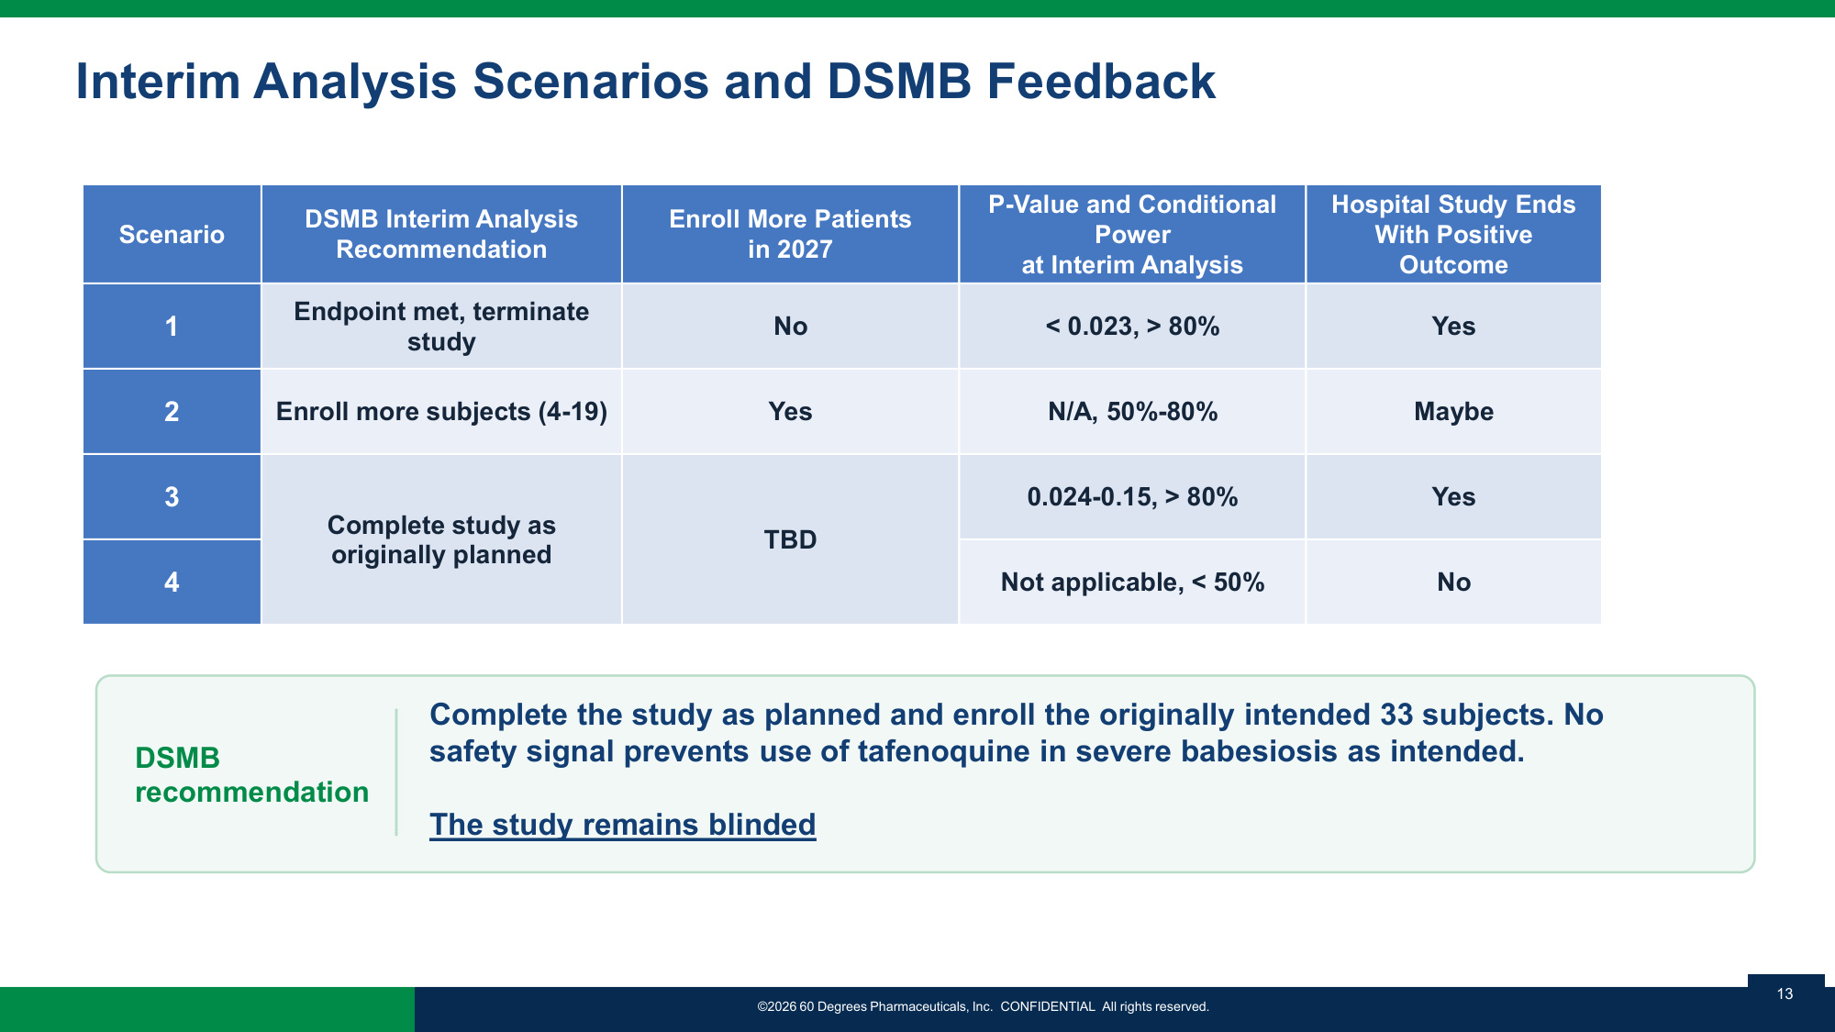
Interim Analysis Scenarios and DSMB Feedback Scenario DSMB Interim Analysis Recommendation Enroll More Patients in 2027 P-Value and Conditional Power at Interim Analysis Hospital Study Ends With Positive Outcome 1 2 3 4 Endpoint met, terminate study Enroll more subjects (4-19) Complete study as originally planned No Yes TBD < 0.023, > 80% N/A, 50%-80% 0.024-0.15, > 80% Not applicable, < 50% Yes Maybe Yes No DSMB recommendation Complete the study as planned and enroll the originally intended 33 subjects. No safety signal prevents use of tafenoquine in severe babesiosis as intended. The study remains blinded ©2026 60 Degrees Pharmaceuticals, Inc. CONFIDENTIAL All rights reserved. 13 13

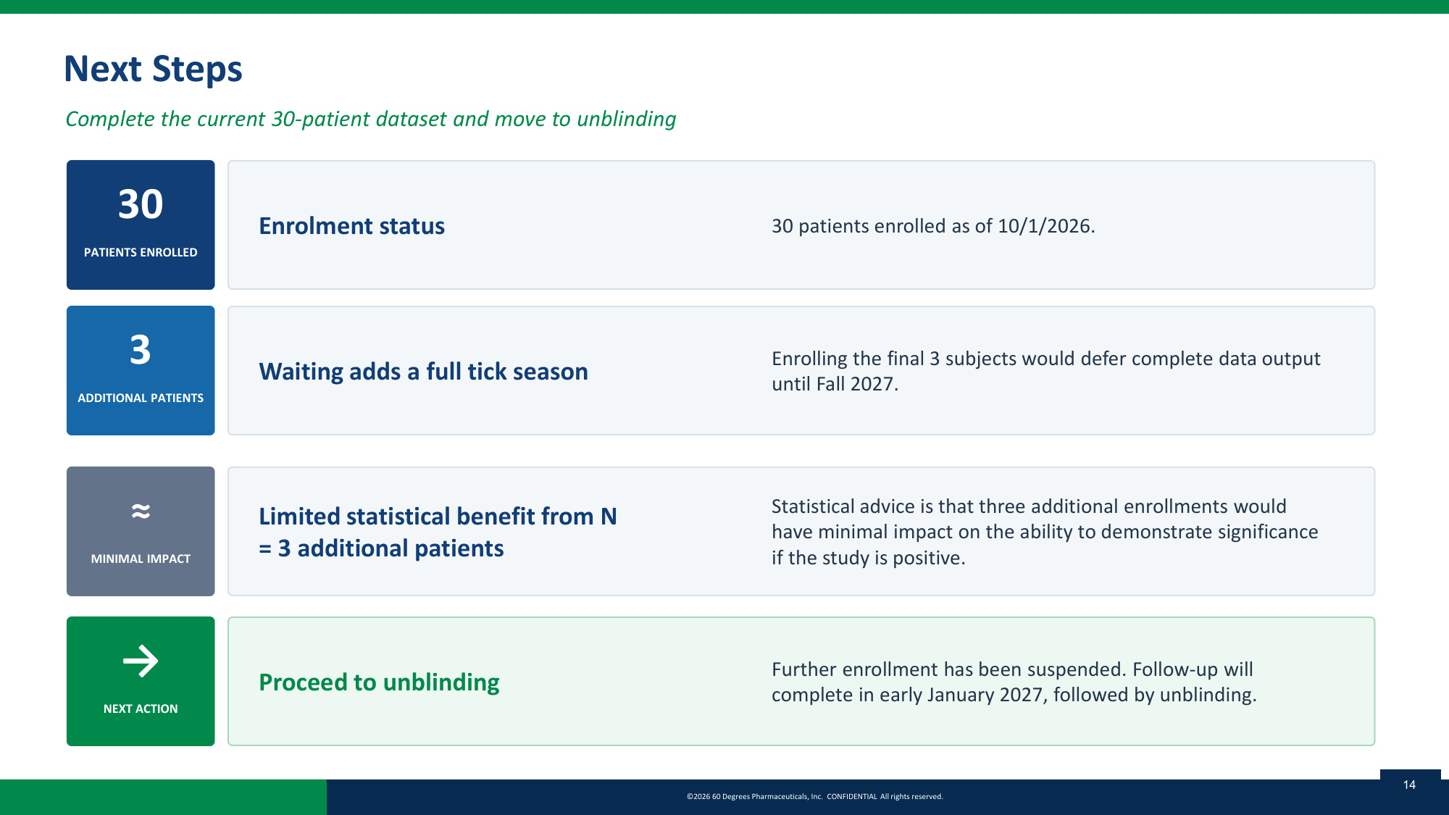
Next Steps Complete the current 30-patient dataset and move to unblinding 30 PATIENTS ENROLLED Enrolment status 30 patients enrolled as of 10/1/2026. 3 ADDITIONAL PATIENTS Waiting adds a full tick season Enrolling the final 3 subjects would defer complete data output until Fall 2027. ≈ MINIMAL IMPACT Limited statistical benefit from N = 3 additional patients Statistical advice is that three additional enrollments would have minimal impact on the ability to demonstrate significance if the study is positive. → NEXT ACTION Proceed to unblinding Further enrollment has been suspended. Follow-up will complete in early January 2027, followed by unblinding. ©2026 60 Degrees Pharmaceuticals, Inc. CONFIDENTIAL All rights reserved. 14 14

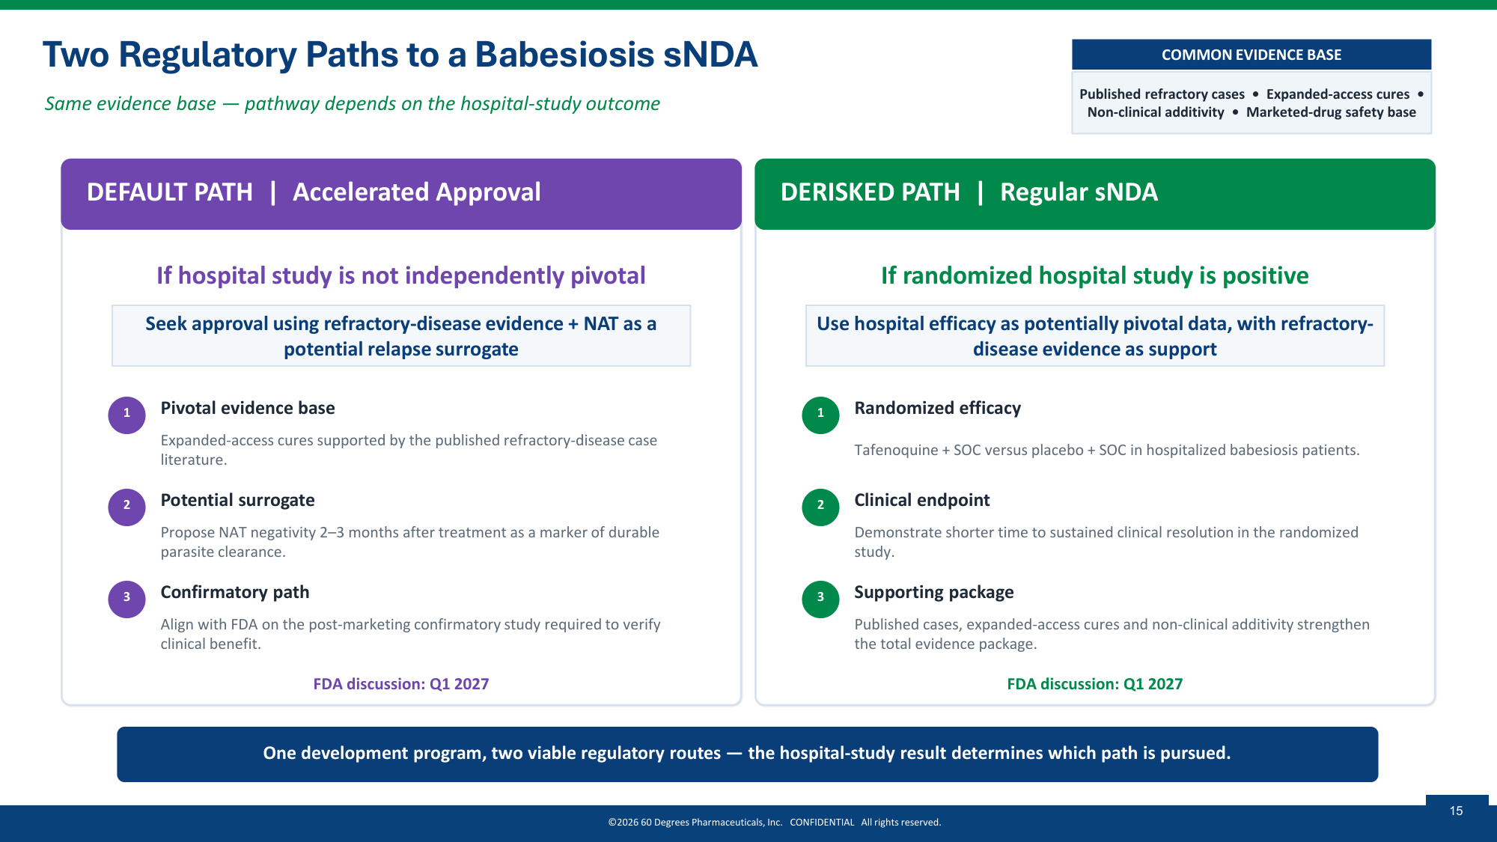
Two Regulatory Paths to a Babesiosis sNDA Same evidence base — pathway depends on the hospital-study outcome COMMON EVIDENCE BASE Published refractory cases • Expanded-access cures • Non-clinical additivity • Marketed-drug safety base DEFAULT PATH | Accelerated Approval If hospital study is not independently pivotal Seek approval using refractory-disease evidence + NAT as a potential relapse surrogate 1 Pivotal evidence base Expanded-access cures supported by the published refractory-disease case literature. 2 Potential surrogate Propose NAT negativity 2–3 months after treatment as a marker of durable parasite clearance. 3 Confirmatory path Align with FDA on the post-marketing confirmatory study required to verify clinical benefit. FDA discussion: Q1 2027 DERISKED PATH | Regular sNDA If randomized hospital study is positive Use hospital efficacy as potentially pivotal data, with refractory- disease evidence as support 1 Randomized efficacy Tafenoquine + SOC versus placebo + SOC in hospitalized babesiosis patients. 2 Clinical endpoint Demonstrate shorter time to sustained clinical resolution in the randomized study. 3 Supporting package Published cases, expanded-access cures and non-clinical additivity strengthen the total evidence package. FDA discussion: Q1 2027 One development program, two viable regulatory routes — the hospital-study result determines which path is pursued. ©2026 60 Degrees Pharmaceuticals, Inc. CONFIDENTIAL All rights reserved. 15 15

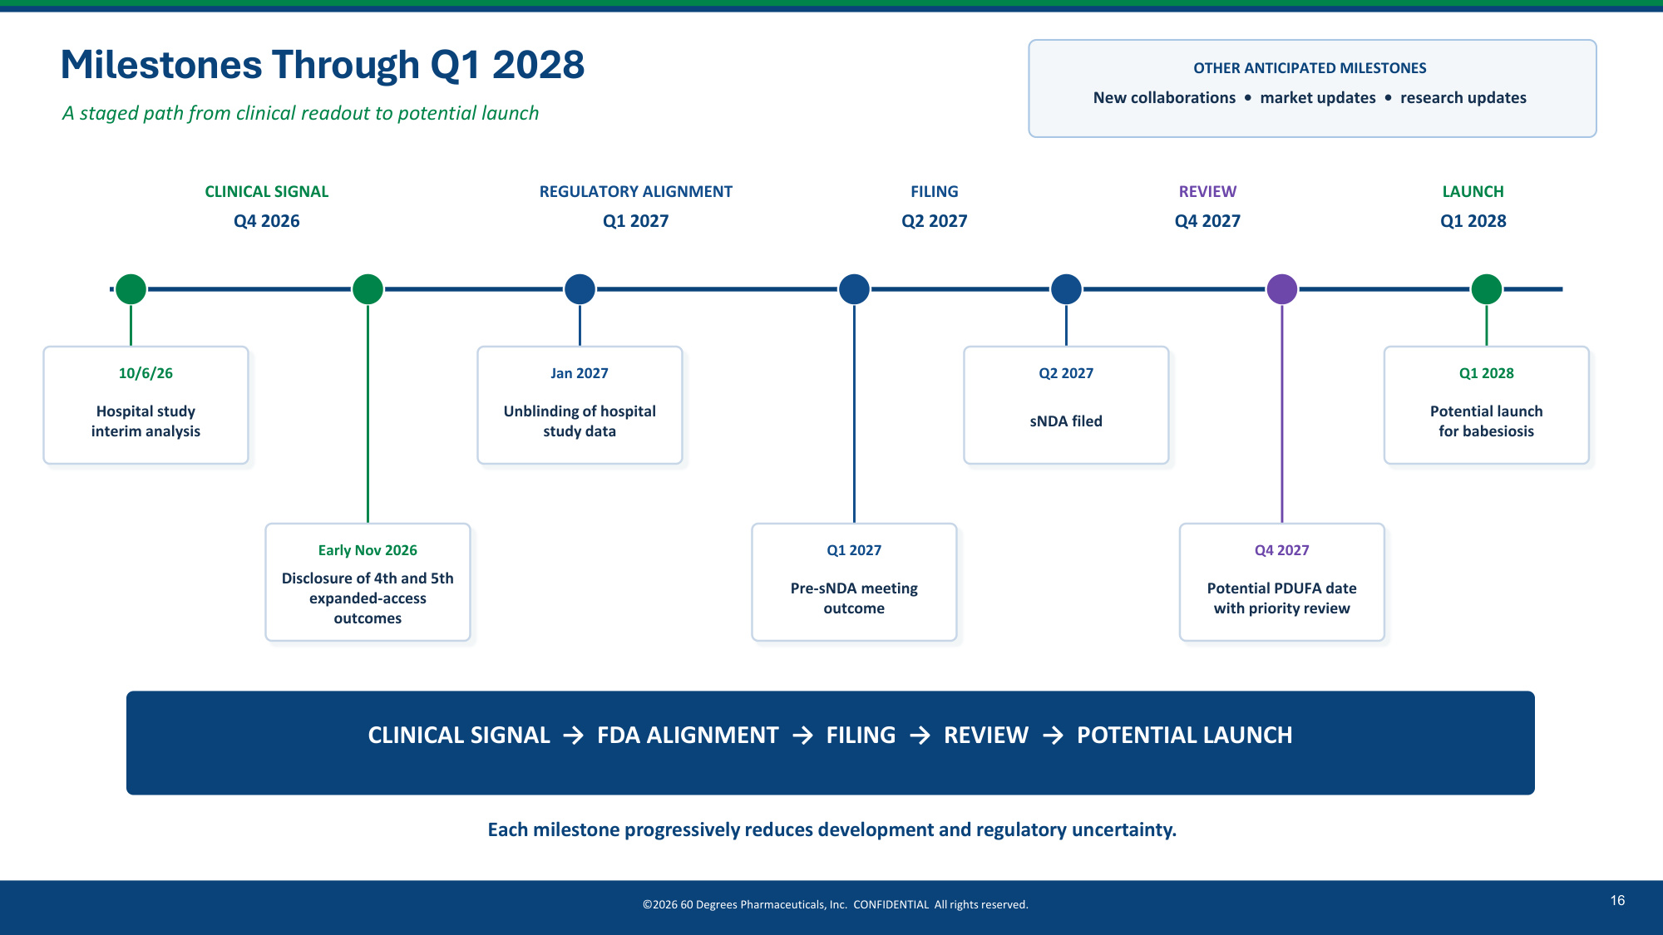
Milestones Through Q1 2028 A staged path from clinical readout to potential launch OTHER ANTICIPATED MILESTONES New collaborations • market updates • research updates CLINICAL SIGNAL Q4 2026 REGULATORY ALIGNMENT Q1 2027 FILING Q2 2027 REVIEW Q4 2027 LAUNCH Q1 2028 10/6/26 Hospital study interim analysis Early Nov 2026 Disclosure of 4th and 5th expanded-access outcomes Jan 2027 Unblinding of hospital study data Q1 2027 Pre-sNDA meeting outcome Q2 2027 sNDA filed Q4 2027 Potential PDUFA date with priority review Q1 2028 Potential launch for babesiosis CLINICAL SIGNAL → FDA ALIGNMENT → FILING → REVIEW → POTENTIAL LAUNCH Each milestone progressively reduces development and regulatory uncertainty. ©2026 60 Degrees Pharmaceuticals, Inc. CONFIDENTIAL All rights reserved. 1616

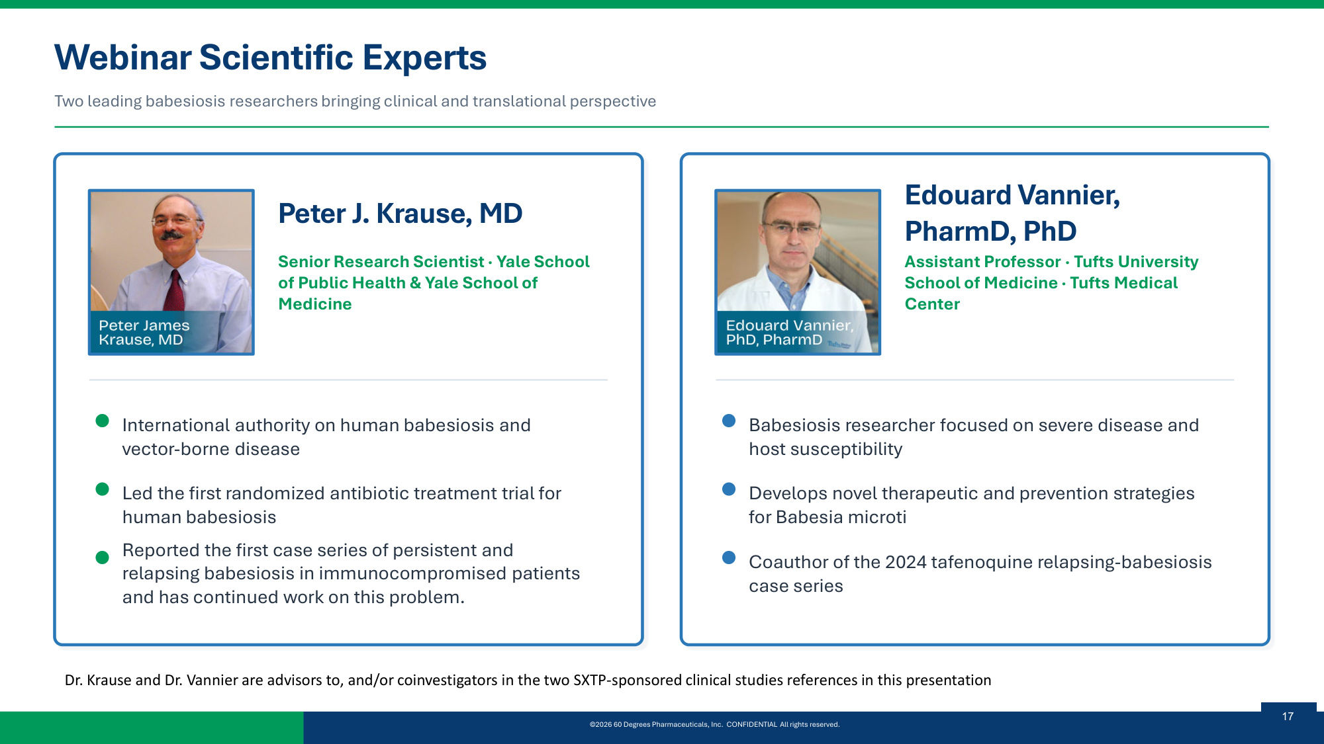
Webinar Scientific Experts Two leading babesiosis researchers bringing clinical and translational perspective Peter J. Krause, MD Senior Research Scientist · Yale School of Public Health & Yale School of Medicine International authority on human babesiosis and vector-borne disease Led the first randomized antibiotic treatment trial for human babesiosis Reported the first case series of persistent and relapsing babesiosis in immunocompromised patients and has continued work on this problem. Edouard Vannier, PharmD, PhD Assistant Professor · Tufts University School of Medicine · Tufts Medical Center Babesiosis researcher focused on severe disease and host susceptibility Develops novel therapeutic and prevention strategies for Babesia microti Coauthor of the 2024 tafenoquine relapsing-babesiosis case series ©2026 60 Degrees Pharmaceuticals, Inc. CONFIDENTIAL All rights reserved. 17 Dr. Krause and Dr. Vannier are advisors to, and/or coinvestigators in the two SXTP-sponsored clinical studies references in this presentation 17

Exhibit 99.2



60 Degrees Pharmaceuticals Plans January 2027 Hospitalized Babesiosis Data Readout; Will Seek Pre-sNDA Meeting with FDA

 | ● | After a scheduled interim analysis of the severe babesiosis study on October 1, 2026, the DSMB recommended completing the study with the originally planned number of patients (N=33); the study remains blinded

 | ● | As of the same date, the Company had enrolled 30 patients

 | ● | Given the limited incremental statistical power from enrolling three additional patients and the seasonal nature of babesiosis, which would otherwise delay unblinding until fall 2027, the Company has decided to conclude enrollment and proceed with unblinding. Primary and secondary endpoint results are expected in January 2027

 | ● | No safety signals were identified in the study

 | ● | Published case reports and the Company’s prospective expanded access study support the potential of tafenoquine-containing regimens in treatment-refractory, relapsing babesiosis, and additional data will be disclosed from this study in early November 2026

 | ● | Company sees a viable regulatory pathway for severe and/or treatment-refractory disease and will request a pre-sNDA meeting with FDA in January 2027 to discuss data requirements, patient population, regulatory pathway, and post-marketing requirements

WASHINGTON, October 6, 2026 (GLOBE NEWSWIRE) -- 60 Degrees Pharmaceuticals, Inc. (NASDAQ: SXTP; SXTPW) (“60 Degrees” or the “Company”), a pharmaceutical company that develops and commercializes new medicines for vector-borne disease, today announced that it intends to conclude enrollment in its randomized clinical study of tafenoquine in patients hospitalized with severe babesiosis at 30 subjects. The Company plans to unblind the study and report its primary and secondary endpoint results in January 2027, and to submit a request for a pre- supplemental New Drug Application (sNDA) meeting with the U.S. Food and Drug Administration (FDA) that same month.

60 Degrees is the sponsor of the double-blind, randomized, multisite, placebo-controlled clinical trial entitled “Oral Tafenoquine Plus Standard of Care Versus Placebo Plus Standard of Care for Babesiosis” (NCT06207370), which is evaluating the efficacy and safety of tafenoquine in treating severe babesiosis in humans. Patients were enrolled at multiple sites in the U.S., including Tufts Medical Center, Rhode Island Hospital, Yale University, Brigham and Women’s Hospital, and Westchester Medical Center.

The DSMB conducted an interim analysis of time to sustained clinical resolution of babesiosis, the study’s primary endpoint, and time to molecular clearance of Babesia parasites, a key secondary endpoint. Following its review, the DSMB recommended completing the initially planned enrollment of 33 patients. As of October 1, 2026, the Company had enrolled 30 subjects. Due to the marginal impact an additional three subjects would have on power to detect a difference on the study endpoints and, the seasonality of babesiosis and its potential to delay unblinding by a year if additional subjects were to be recruited, the Company intends to proceed with final analysis of the enrolled population. The DSMB’s recommendation does not establish whether the study met its endpoints; those results will be determined following unblinding and final analysis. The DSMB analysis did not identify any safety issues.

A growing body of published case reports suggests that tafenoquine, administered in combination with atovaquone-containing regimens for at least eight weeks, may achieve a high cure rate in high-risk patients with treatment-refractory, relapsing babesiosis. Consistent with these reports, the Company has confirmed molecular cure, using a highly sensitive nucleic acid amplification test (NAT), in the first three patients enrolled in its expanded access study of tafenoquine combined with atovaquone-containing regimens in relapsing, treatment-refractory babesiosis (“Expanded Use in Persistent B. Microti Babesiosis” — NCT06478641). Final screening data from two additional patients are expected in early November 2026. Irrespective of the ultimate results of the severe babesiosis study to be reported in January, the Company believes an approval pathway based on case reports in the treatment-refractory population is possible.

The Company intends to request a pre-sNDA meeting with FDA to discuss the clinical evidence and data requirements for an sNDA submission for tafenoquine treatment of babesiosis. Should the data package be supported by literature and expanded access cases only, the Company plans to ask FDA to consider NAT-based molecular clearance as a surrogate endpoint reasonably likely to predict clinical benefit, potentially supporting an accelerated approval pathway. The Company would also propose a post-approval confirmatory study in an appropriate patient population. The availability of an accelerated approval pathway and the adequacy of the submission will be subject to FDA review.

No FDA-approved treatment or vaccine exists for human babesiosis. While tafenoquine is approved for the prevention of malaria, it is not currently approved by FDA for the treatment or prevention of babesiosis.

About Babesiosis

Babesiosis is a tick-borne illness caused by Babesia parasites that develop and multiply in red blood cells. It is often found as a co-infection of Lyme disease. Symptoms include fevers, chills, sweats, and fatigue. In severely immunocompromised patients, standard antimicrobial regimens can fail to clear infection, resulting in relapsing disease that may persist for months or years and has been associated with the emergence of antimicrobial-resistant Babesia strains. Incidence of babesiosis is rapidly rising, particularly in the Northeast, and the Centers for Disease Control and Prevention has advised that emergency room visits for tick bites are currently at historically high levels in many regions of the U.S.

2

About 60 Degrees Pharmaceuticals, Inc.

60 Degrees Pharmaceuticals, Inc., founded in 2010, develops and commercializes new medicines for the treatment and prevention of vector-borne disease. The Company won U.S. Food and Drug Administration approval of its lead product, ARAKODA® (tafenoquine), for malaria prevention in 2018 and currently has 3 active clinical trials underway for babesiosis, an emerging tick-borne disease. ARAKODA is sold commercially in the U.S. and Australia. 60 Degrees also collaborates with prominent research and academic organizations in the U.S. and Australia to advance science around vector-borne disease. The Company is headquartered in Washington, D.C., with a subsidiary in Australia. Learn more at www.60degreespharma.com.

Cautionary Note Regarding Forward-Looking Statements

This press release may contain “forward-looking statements” within the meaning of the safe harbor provisions of the U.S. Private Securities Litigation Reform Act of 1995. Forward-looking statements reflect the current view about future events. When used in this press release, the words “anticipate,” “believe,” “estimate,” “expect,” “future,” “intend,” “plan,” or the negative of these terms and similar expressions, as they relate to us or our management, identify forward-looking statements. Forward-looking statements are neither historical facts nor assurances of future performance. Instead, they are based only on our current beliefs, expectations and assumptions regarding the future of our business, future plans and strategies, projections, anticipated events and trends, the economy, activities of regulators and future regulations and other future conditions. Because forward-looking statements relate to the future, they are subject to inherent uncertainties, risks and changes in circumstances that are difficult to predict and many of which are outside of our control. Our actual results and financial condition may differ materially from those indicated in the forward-looking statements. Therefore, you should not rely on any of these forward-looking statements. Important factors that could cause our actual results and financial condition to differ materially from those indicated in the forward-looking statements include, among others, the following: there is substantial doubt as to our ability to continue on a going-concern basis; we might not be eligible for Australian government research and development tax rebates; if we are not able to successfully develop, obtain FDA approval for, and provide for the commercialization of non-malaria prevention indications for tafenoquine (ARAKODA® or other regimen) or Celgosivir in a timely manner, we may not be able to expand our business operations; we may not be able to successfully conduct planned clinical trials; and we have no manufacturing capacity which puts us at risk of lengthy and costly delays of bringing our products to market. More detailed information about the Company and the risk factors that may affect the realization of forward-looking statements is set forth in the Company’s filings with the Securities and Exchange Commission (“SEC”), including the information contained in our Annual Report on Form 10-K filed with the SEC on March 30, 2026, and our subsequent SEC filings. Investors and security holders are urged to read these documents free of charge on the SEC’s website at www.sec.gov. As a result of these matters, changes in facts, assumptions not being realized, or other circumstances, the Company’s actual results may differ materially from the expected results discussed in the forward-looking statements contained in this press release. Any forward-looking statement made by us in this press release is based only on information currently available to us and speaks only as of the date on which it is made. We undertake no obligation to publicly update any forward-looking statement, whether written or oral, that may be made from time to time, whether as a result of new information, future developments or otherwise.

Media Contact:
Kristen Landon kristenlandon@60degreespharma.com

Investor Contact:
Patrick Gaynes patrickgaynes@60degreespharma.com

3

