UNITED STATES
SECURITIES AND EXCHANGE COMMISSION
WASHINGTON, D.C. 20549

FORM 8-K

CURRENT REPORT
PURSUANT TO SECTION 13 OR 15(d)
OF THE SECURITIES EXCHANGE ACT OF 1934

Date of Report (Date of earliest event reported): July 20, 2026

60 DEGREES PHARMACEUTICALS, INC.
(Exact name of registrant as specified in its charter)

Delaware |  | 001-41719 |  | 45-2406880
(State or other jurisdiction  of Incorporation) |  | (Commission File Number) |  | (IRS Employer  Identification Number)

1025 Connecticut Avenue NW Suite 1000,  Washington, D.C. |  | 20036
(Address of registrant’s principal executive office) |  | (Zip code)

(202) 327-5422
(Registrant’s telephone number, including area code)

Not Applicable
(Former name or former address, if changed since last report)

Check the appropriate box below if the Form 8-K filing is intended to simultaneously satisfy the filing obligation of the registrant under any of the following provisions (see General Instruction A.2. below):

☐ | Written communications pursuant to Rule 425 under the Securities Act (17 CFR 230.425)

☐ | Soliciting material pursuant to Rule 14a-12 under the Exchange Act (17 CFR 240.14a-12)

☐ | Pre-commencement communications pursuant to Rule 14d-2(b) under the Exchange Act (17 CFR 240.14d-2(b))

☐ | Pre-commencement communications pursuant to Rule 13e-4(c) under the Exchange Act (17 CFR 240.13e-4(c))

Securities registered pursuant to Section 12(b) of the Act:

Title of each class |  | Trading symbol(s) |  | Name of each exchange on which registered
Common Stock, par value $0.0001 per share |  | SXTP |  | The Nasdaq Stock Market LLC
Warrants, each warrant to purchase one share of Common Stock |  | SXTPW |  | The Nasdaq Stock Market LLC

Indicate by check mark whether the registrant is an emerging growth company as defined in Rule 405 of the Securities Act of 1933 (§230.405 of this chapter) or Rule 12b-2 of the Securities Exchange Act of 1934 (§240.12b-2 of this chapter).

Emerging growth company ☒

If an emerging growth company, indicate by check mark if the registrant has elected not to use the extended transition period for complying with any new or revised financial accounting standards provided pursuant to Section 13(a) of the Exchange Act. ☐

Item 7.01 Regulation FD Disclosure

On July 20, 2026, the Company updated its investor presentation, which it intends to use from time to time in meetings with investors, analysts and other members of the investment community. A copy of the updated investor presentation is furnished as Exhibit 99.1 to this Current Report on Form 8-K and is incorporated herein by reference.

The information furnished pursuant to this Item 7.01, including Exhibit 99.1, shall not be deemed "filed" for purposes of Section 18 of the Securities Exchange Act of 1934, as amended, or otherwise subject to the liabilities of that section, nor shall it be deemed incorporated by reference into any filing under the Securities Act of 1933, as amended, or the Securities Exchange Act of 1934, as amended, except as expressly set forth by specific reference in such filing.

Cautionary Statement Regarding Forward-Looking Statements

This Current Report on Form 8-K includes forward-looking statements within the meaning of the Private Securities Litigation Reform Act of 1995. Such statements involve risks and uncertainties that could cause the Company’s actual results and financial position to differ materially. These risks and uncertainties include uncertainties associated with market conditions and other risks described under the heading “Risk Factors” in the Company’s SEC Filings on Form 10-K and Form 10-Q. The Company assumes no responsibility to update or revise any forward-looking statements to reflect events, trends or circumstances after the date hereof.

Item 9.01 Financial Statements and Exhibits

(a) Exhibits

Number |  | Description
99.1 |  | 60 Degrees Pharmaceuticals, Inc. Investor Presentation, dated July 20, 2026
104 |  | Cover Page Interactive Data File (embedded within the Inline XBRL document)

1

SIGNATURES

Pursuant to the requirements of the Securities Exchange Act of 1934, the registrant has duly caused this report to be signed on its behalf by the undersigned hereunto duly authorized.

 | 60 DEGREES PHARMACEUTICALS, INC.
Date: July 20, 2026 | By: | /s/ Geoffrey Dow
 | Name: | Geoffrey Dow
 | Title: | Chief Executive Officer and President

2

Exhibit 99.1

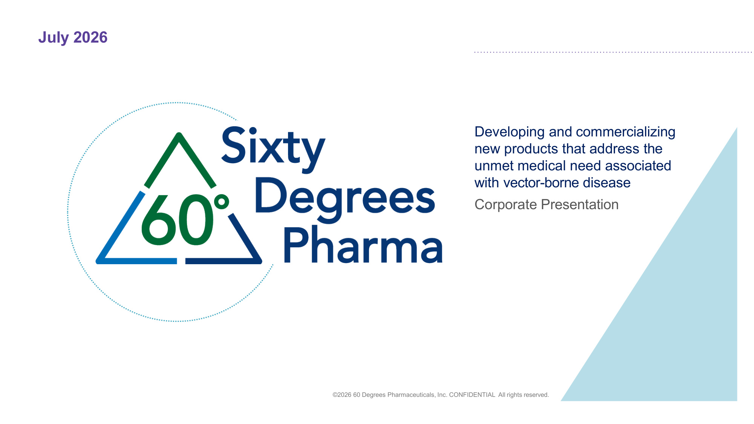
July 2026 Developing and commercializing new products that address the unmet medical need associated with vector-borne disease Corporate Presentation ©2026 60 Degrees Pharmaceuticals, Inc. CONFIDENTIAL All rights reserved.

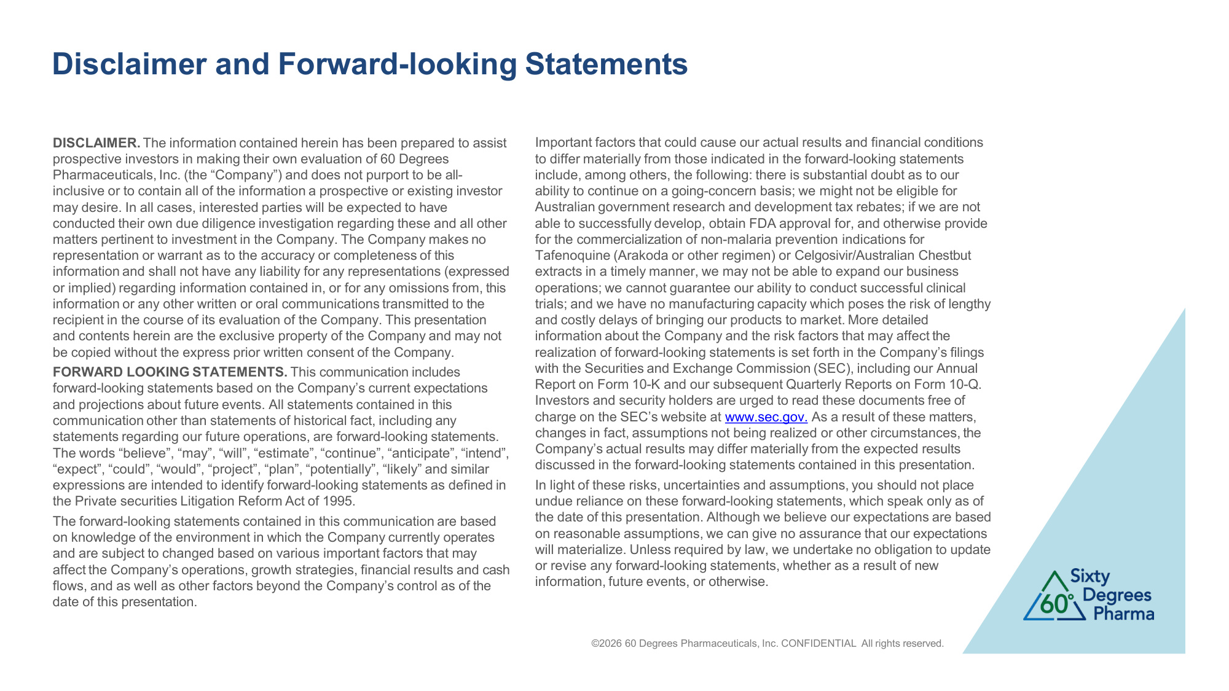
Disclaimer and Forward-looking Statements ©2026 60 Degrees Pharmaceuticals, Inc. CONFIDENTIAL All rights reserved. DISCLAIMER. The information contained herein has been prepared to assist prospective investors in making their own evaluation of 60 Degrees Pharmaceuticals, Inc. (the "Company") and does not purport to be all- inclusive or to contain all of the information a prospective or existing investor may desire. In all cases, interested parties will be expected to have conducted their own due diligence investigation regarding these and all other matters pertinent to investment in the Company. The Company makes no representation or warrant as to the accuracy or completeness of this information and shall not have any liability for any representations (expressed or implied) regarding information contained in, or for any omissions from, this information or any other written or oral communications transmitted to the recipient in the course of its evaluation of the Company. This presentation and contents herein are the exclusive property of the Company and may not be copied without the express prior written consent of the Company. FORWARD LOOKING STATEMENTS. This communication includes forward-looking statements based on the Company's current expectations and projections about future events. All statements contained in this communication other than statements of historical fact, including any statements regarding our future operations, are forward-looking statements. The words "believe", "may", "will", "estimate", "continue", "anticipate", "intend", "expect", "could", "would", "project", "plan", "potentially", "likely" and similar expressions are intended to identify forward-looking statements as defined in the Private securities Litigation Reform Act of 1995. The forward-looking statements contained in this communication are based on knowledge of the environment in which the Company currently operates and are subject to changed based on various important factors that may affect the Company's operations, growth strategies, financial results and cash flows, and as well as other factors beyond the Company's control as of the date of this presentation. Important factors that could cause our actual results and financial conditions to differ materially from those indicated in the forward-looking statements include, among others, the following: there is substantial doubt as to our ability to continue on a going-concern basis; we might not be eligible for Australian government research and development tax rebates; if we are not able to successfully develop, obtain FDA approval for, and otherwise provide for the commercialization of non-malaria prevention indications for Tafenoquine (Arakoda or other regimen) or Celgosivir/Australian Chestbut extracts in a timely manner, we may not be able to expand our business operations; we cannot guarantee our ability to conduct successful clinical trials; and we have no manufacturing capacity which poses the risk of lengthy and costly delays of bringing our products to market. More detailed information about the Company and the risk factors that may affect the realization of forward-looking statements is set forth in the Company's filings with the Securities and Exchange Commission (SEC), including our Annual Report on Form 10-K and our subsequent Quarterly Reports on Form 10-Q. Investors and security holders are urged to read these documents free of charge on the SEC's website at www.sec.gov. As a result of these matters, changes in fact, assumptions not being realized or other circumstances, the Company's actual results may differ materially from the expected results discussed in the forward-looking statements contained in this presentation. In light of these risks, uncertainties and assumptions, you should not place undue reliance on these forward-looking statements, which speak only as of the date of this presentation. Although we believe our expectations are based on reasonable assumptions, we can give no assurance that our expectations will materialize. Unless required by law, we undertake no obligation to update or revise any forward-looking statements, whether as a result of new information, future events, or otherwise.

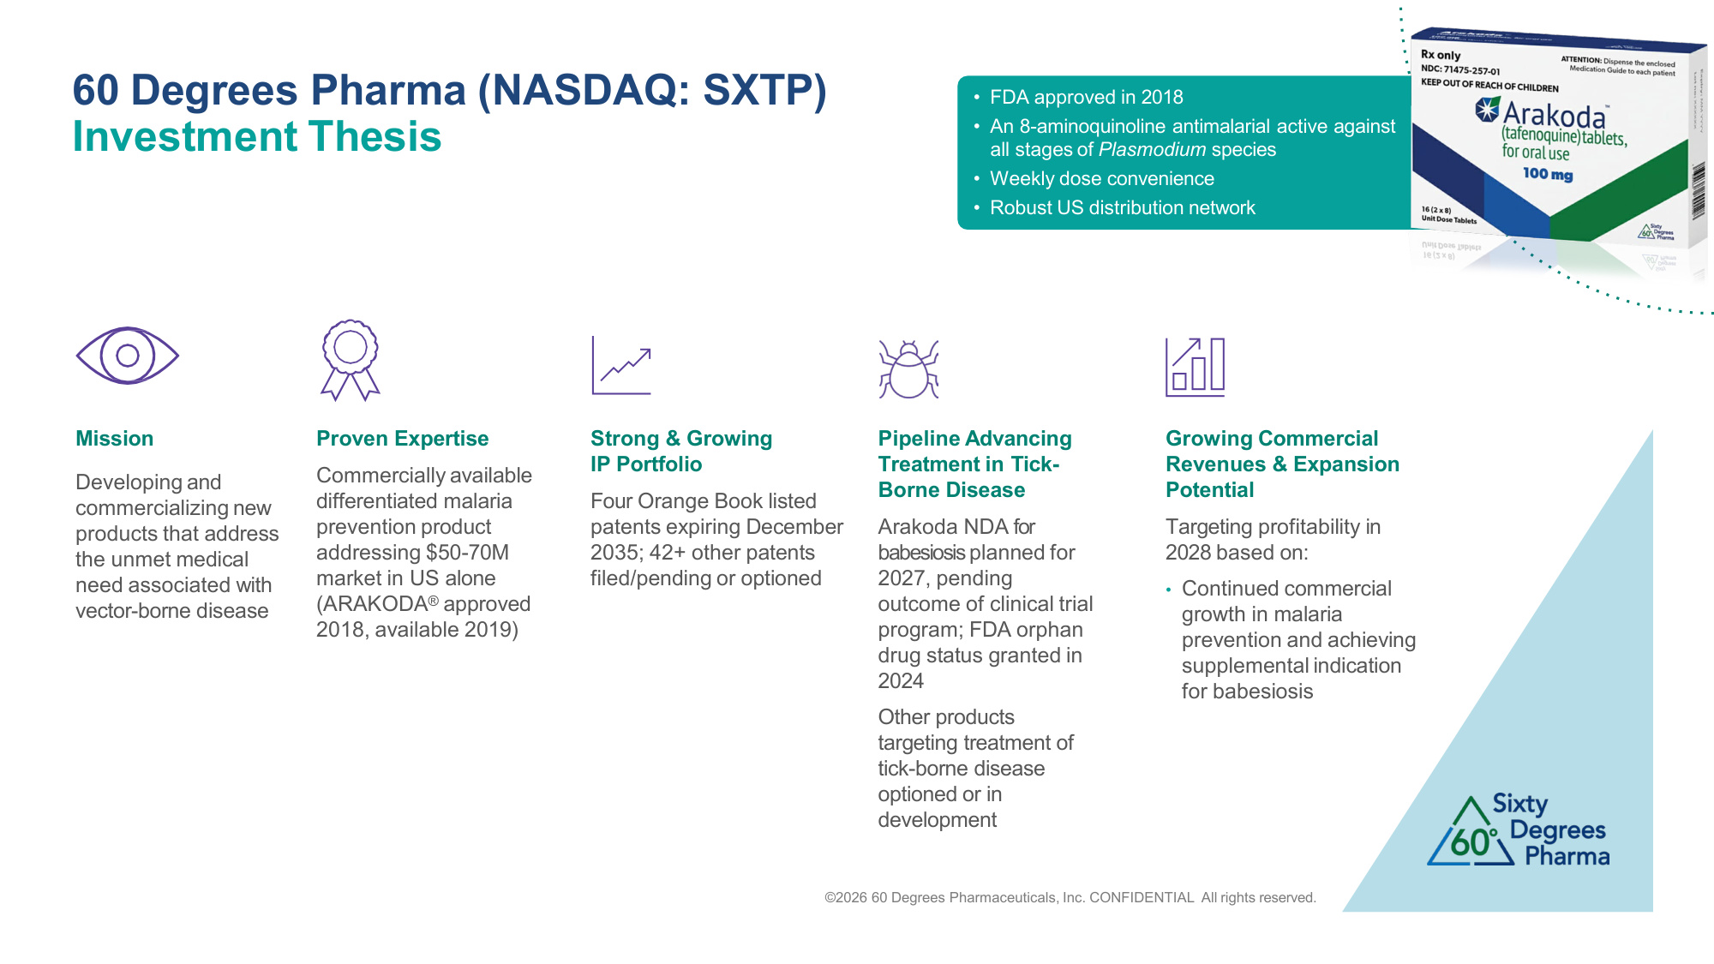
• FDA approved in 2018 • An 8-aminoquinoline antimalarial active against all stages of Plasmodium species • Weekly dose convenience • Robust US distribution network 60 Degrees Pharma (NASDAQ: SXTP) Investment Thesis Mission Developing and commercializing new products that address the unmet medical need associated with vector-borne disease Proven Expertise Commercially available differentiated malaria prevention product addressing $50-70M market in US alone (ARAKODA® approved 2018, available 2019) Strong & Growing IP Portfolio Four Orange Book listed patents expiring December 2035; 42+ other patents filed/pending or optioned Pipeline Advancing Treatment in Tick- Borne Disease Arakoda NDA for babesiosis planned for 2027, pending outcome of clinical trial program; FDA orphan drug status granted in 2024 Other products targeting treatment of tick-borne disease optioned or in development Growing Commercial Revenues & Expansion Potential Targeting profitability in 2028 based on: • Continued commercial growth in malaria prevention and achieving supplemental indication for babesiosis ©2026 60 Degrees Pharmaceuticals, Inc. CONFIDENTIAL All rights reserved.

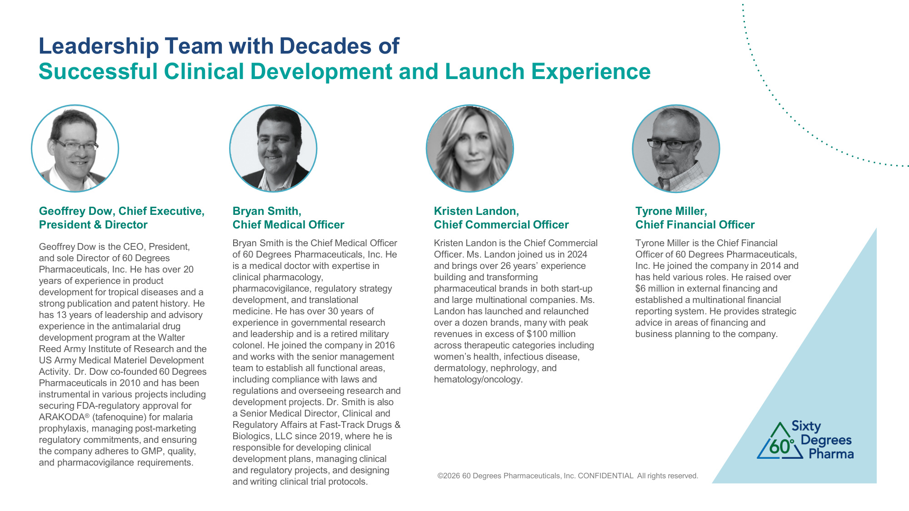
©2026 60 Degrees Pharmaceuticals, Inc. CONFIDENTIAL All rights reserved. Leadership Team with Decades of Successful Clinical Development and Launch Experience Geoffrey Dow, Chief Executive, President & Director Geoffrey Dow is the CEO, President, and sole Director of 60 Degrees Pharmaceuticals, Inc. He has over 20 years of experience in product development for tropical diseases and a strong publication and patent history. He has 13 years of leadership and advisory experience in the antimalarial drug development program at the Walter Reed Army Institute of Research and the US Army Medical Materiel Development Activity. Dr. Dow co-founded 60 Degrees Pharmaceuticals in 2010 and has been instrumental in various projects including securing FDA-regulatory approval for ARAKODA® (tafenoquine) for malaria prophylaxis, managing post-marketing regulatory commitments, and ensuring the company adheres to GMP, quality, and pharmacovigilance requirements. Bryan Smith, Chief Medical Officer Bryan Smith is the Chief Medical Officer of 60 Degrees Pharmaceuticals, Inc. He is a medical doctor with expertise in clinical pharmacology, pharmacovigilance, regulatory strategy development, and translational medicine. He has over 30 years of experience in governmental research and leadership and is a retired military colonel. He joined the company in 2016 and works with the senior management team to establish all functional areas, including compliance with laws and regulations and overseeing research and development projects. Dr. Smith is also a Senior Medical Director, Clinical and Regulatory Affairs at Fast-Track Drugs & Biologics, LLC since 2019, where he is responsible for developing clinical development plans, managing clinical and regulatory projects, and designing and writing clinical trial protocols. Kristen Landon, Chief Commercial Officer Kristen Landon is the Chief Commercial Officer. Ms. Landon joined us in 2024 and brings over 26 years' experience building and transforming pharmaceutical brands in both start-up and large multinational companies. Ms. Landon has launched and relaunched over a dozen brands, many with peak revenues in excess of $100 million across therapeutic categories including women's health, infectious disease, dermatology, nephrology, and hematology/oncology. Tyrone Miller, Chief Financial Officer Tyrone Miller is the Chief Financial Officer of 60 Degrees Pharmaceuticals, Inc. He joined the company in 2014 and has held various roles. He raised over $6 million in external financing and established a multinational financial reporting system. He provides strategic advice in areas of financing and business planning to the company.

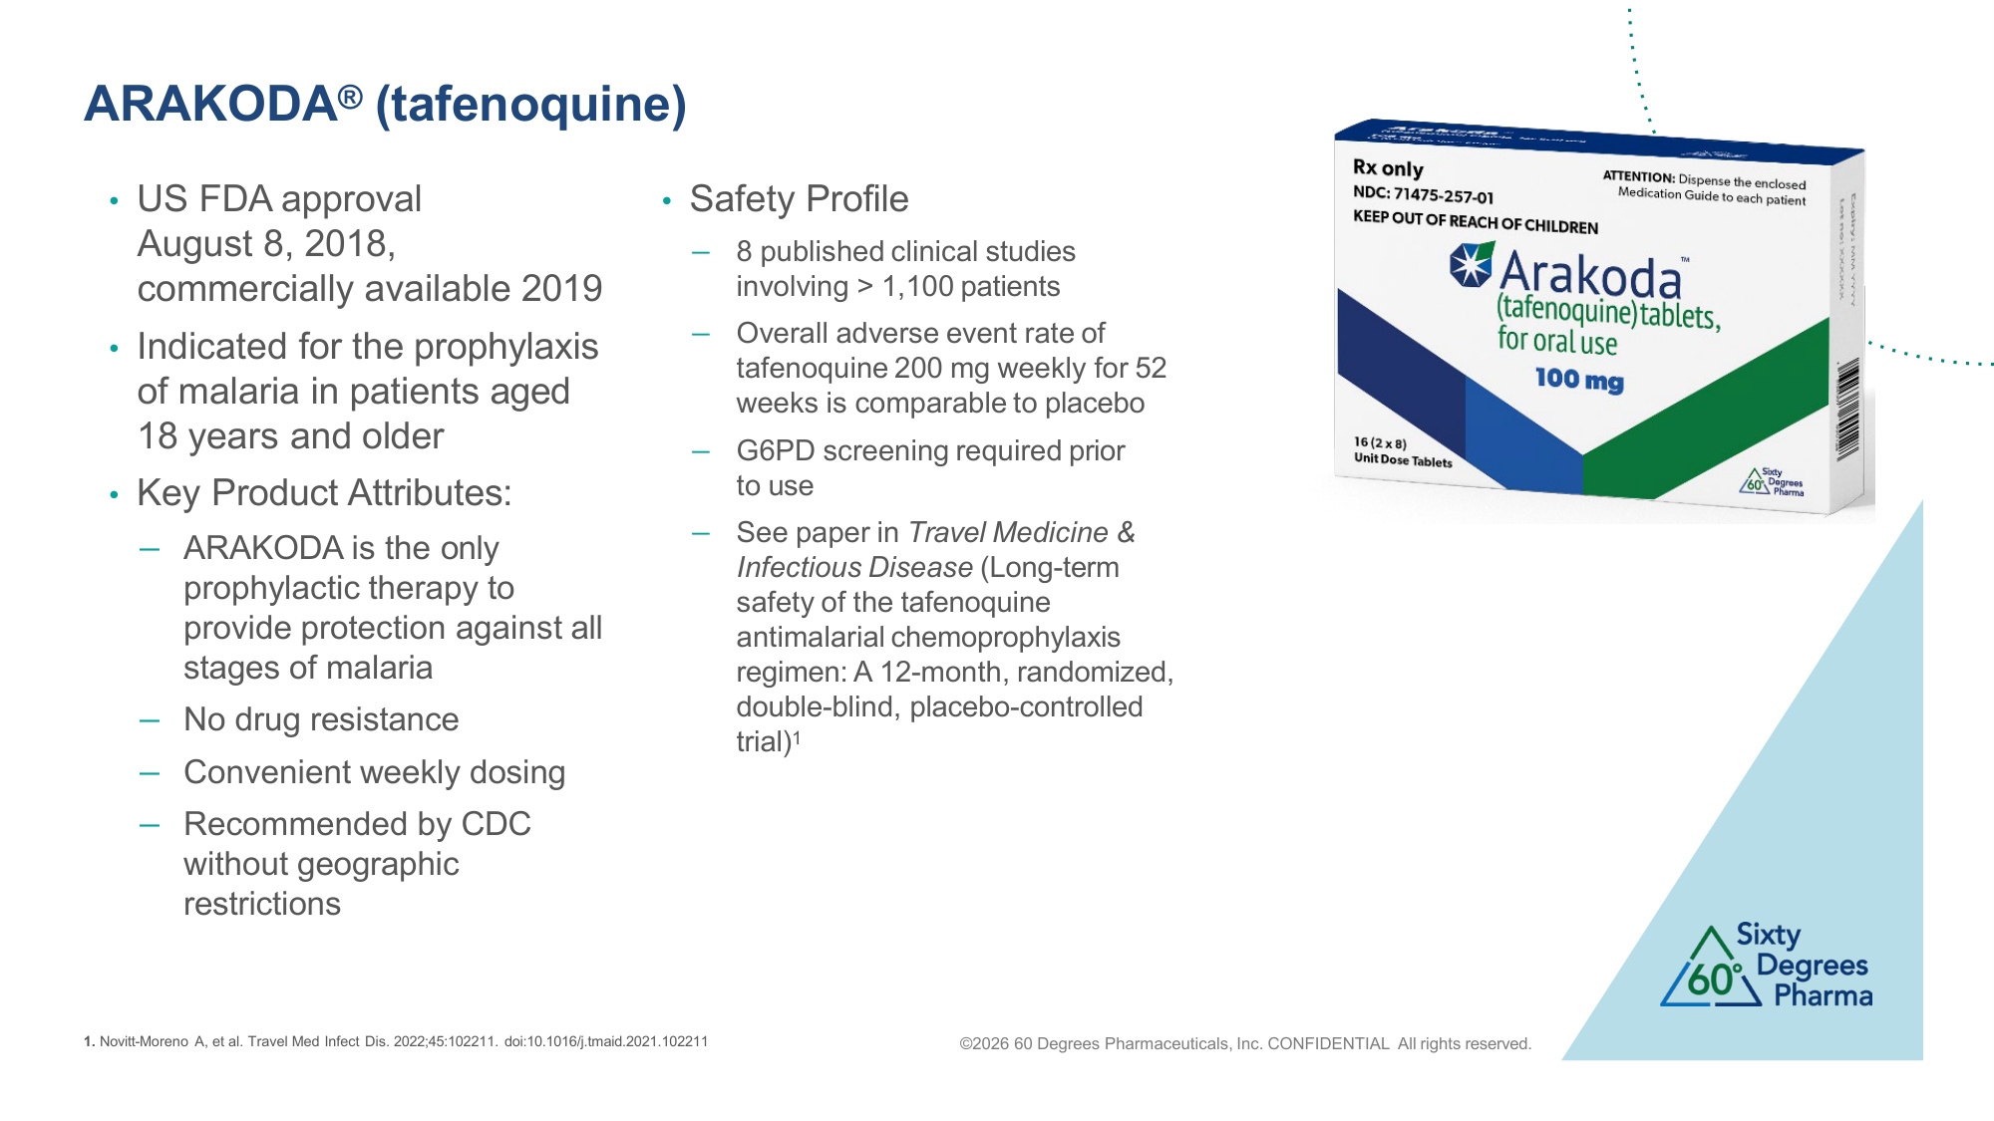
©2026 60 Degrees Pharmaceuticals, Inc. CONFIDENTIAL All rights reserved. ARAKODA® (tafenoquine) • US FDA approval August 8, 2018, commercially available 2019 • Indicated for the prophylaxis of malaria in patients aged 18 years and older • Key Product Attributes: − ARAKODA is the only prophylactic therapy to provide protection against all stages of malaria − No drug resistance − Convenient weekly dosing − Recommended by CDC without geographic restrictions • Safety Profile − 8 published clinical studies involving > 1,100 patients − Overall adverse event rate of tafenoquine 200 mg weekly for 52 weeks is comparable to placebo − G6PD screening required prior to use − See paper in Travel Medicine & Infectious Disease (Long-term safety of the tafenoquine antimalarial chemoprophylaxis regimen: A 12-month, randomized, double-blind, placebo-controlled trial)1 1. Novitt-Moreno A, et al. Travel Med Infect Dis. 2022;45:102211. doi:10.1016/j.tmaid.2021.102211

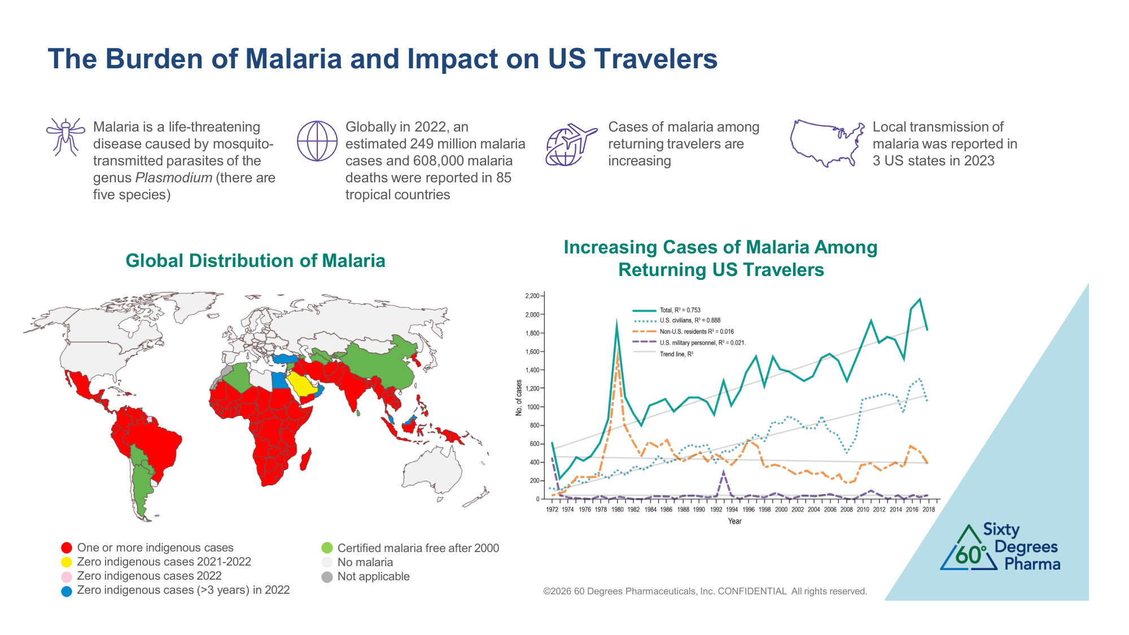
©2026 60 Degrees Pharmaceuticals, Inc. CONFIDENTIAL All rights reserved. The Burden of Malaria and Impact on US Travelers Global Distribution of Malaria Increasing Cases of Malaria Among Returning US Travelers Malaria is a life-threatening disease caused by mosquito- transmitted parasites of the genus Plasmodium (there are five species) Globally in 2022, an estimated 249 million malaria cases and 608,000 malaria deaths were reported in 85 tropical countries Cases of malaria among returning travelers are increasing Local transmission of malaria was reported in 3 US states in 2023 One or more indigenous cases Zero indigenous cases 2021-2022 Zero indigenous cases 2022 Zero indigenous cases (>3 years) in 2022 Certified malaria free after 2000 No malaria Not applicable

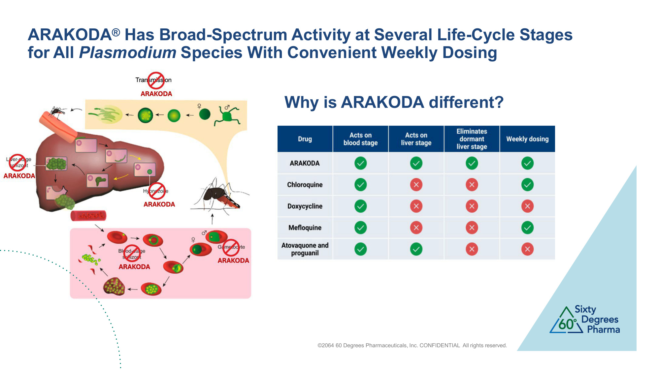
©2064 60 Degrees Pharmaceuticals, Inc. CONFIDENTIAL All rights reserved. ARAKODA® Has Broad-Spectrum Activity at Several Life-Cycle Stages for All Plasmodium Species With Convenient Weekly Dosing Why is ARAKODA different?

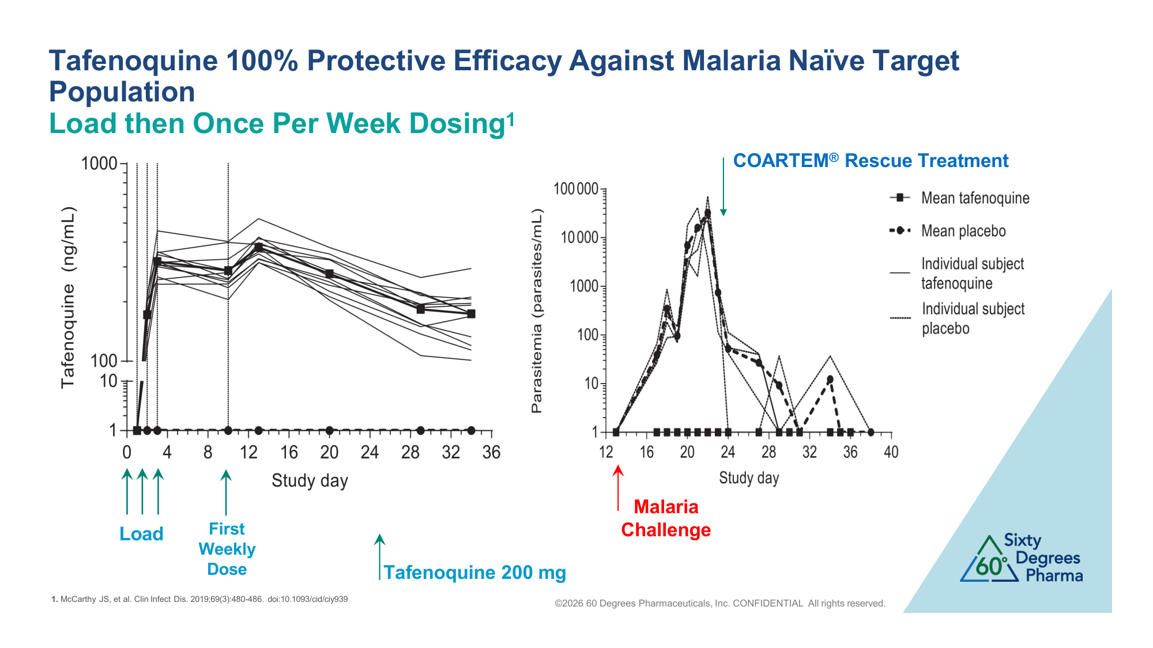
Tafenoquine 200 mg ©2026 60 Degrees Pharmaceuticals, Inc. CONFIDENTIAL All rights reserved. Tafenoquine 100% Protective Efficacy Against Malaria Naïve Target Population Load then Once Per Week Dosing1 1. McCarthy JS, et al. Clin Infect Dis. 2019;69(3):480-486. doi:10.1093/cid/ciy939 Load First Weekly Dose COARTEM® Rescue Treatment Malaria Challenge

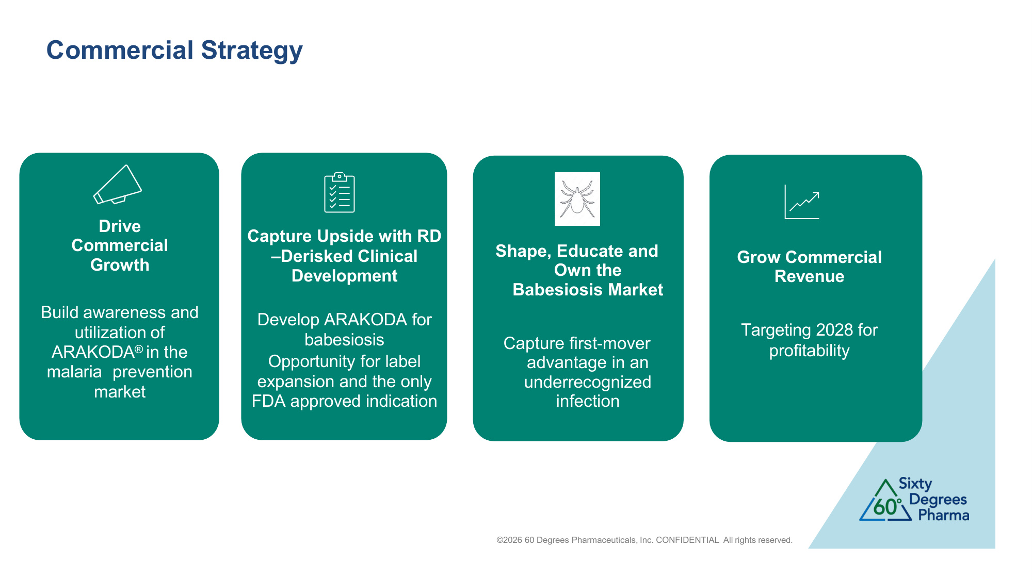
Commercial Strategy Drive Commercial Growth Build awareness and utilization of ARAKODA® in the malaria prevention market Shape, Educate and Own the Babesiosis Market Capture first-mover advantage in an underrecognized infection Grow Commercial Revenue Targeting Q4 2026 for profitability ©2026 60 Degrees Pharmaceuticals, Inc. CONFIDENTIAL All rights reserved. Capture Upside with RD –Derisked Clinical Development Develop ARAKODA for babesiosis Opportunity for label expansion and the only FDA approved indication Grow Commercial Revenue Targeting 2028 for profitability

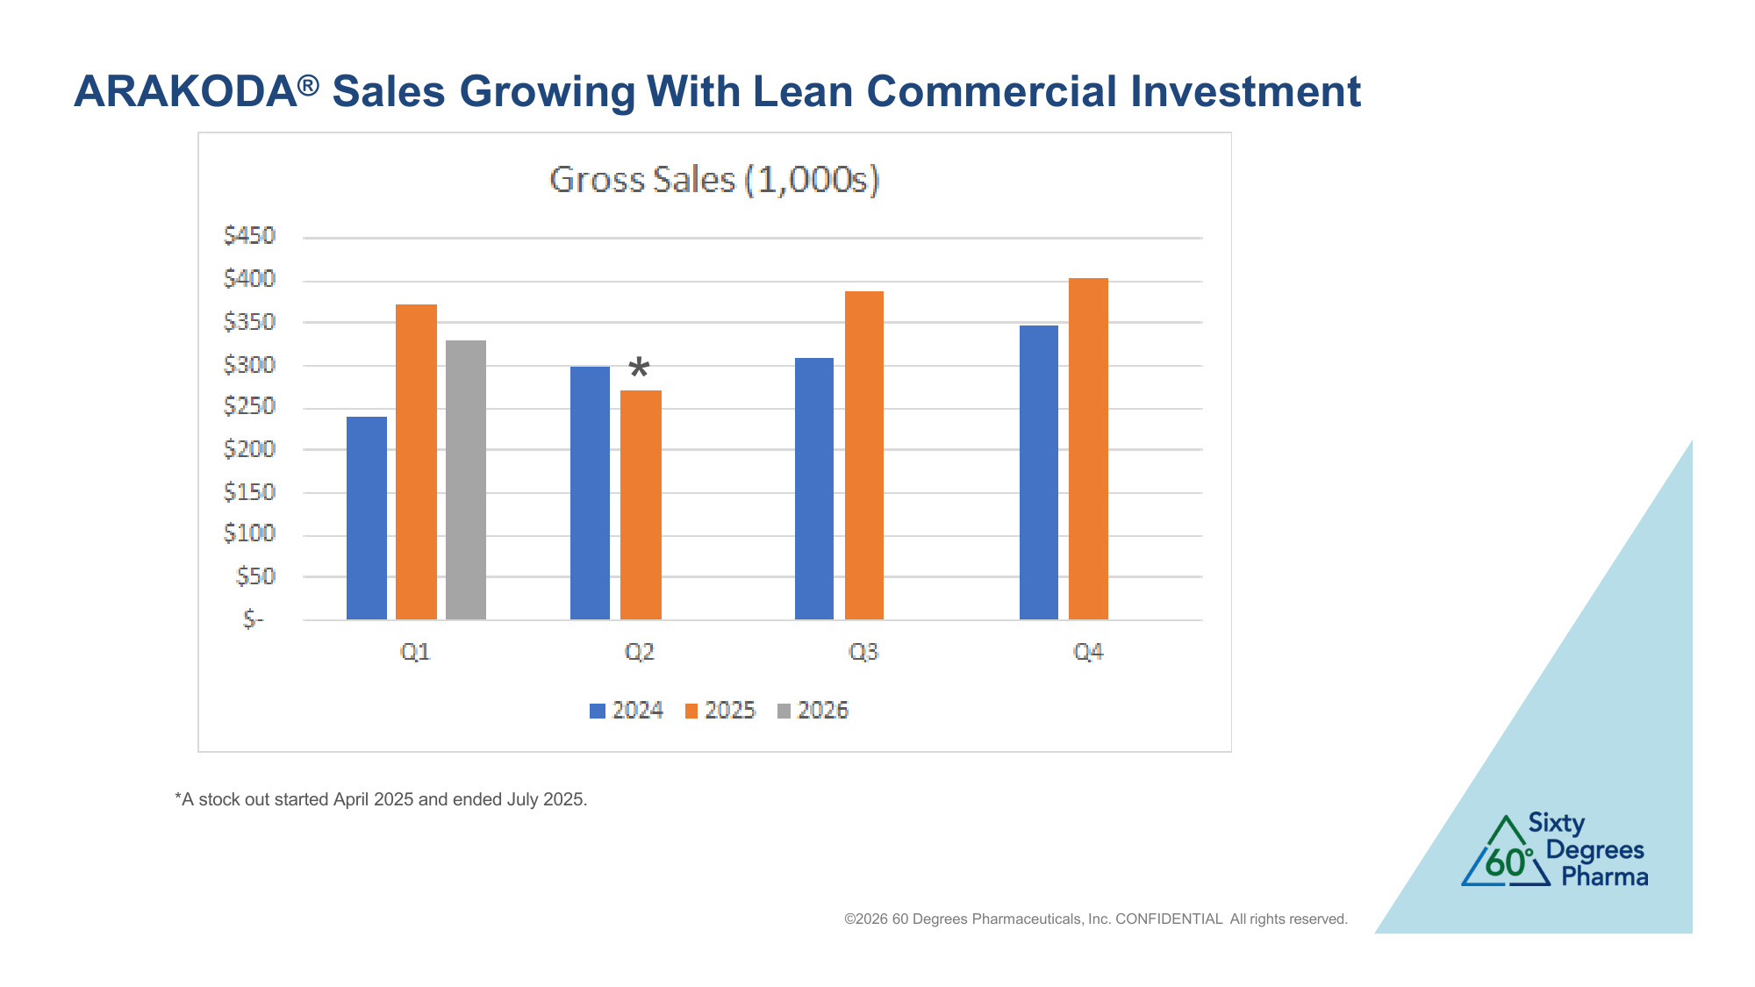
ARAKODA® Sales Growing With Lean Commercial Investment *A stock out started April 2025 and ended July 2025. ©2026 60 Degrees Pharmaceuticals, Inc. CONFIDENTIAL All rights reserved. *

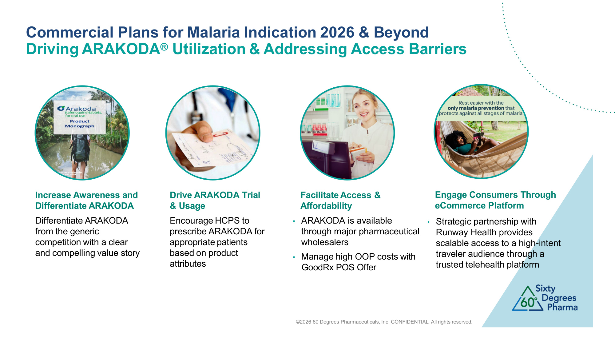
Commercial Plans for Malaria Indication 2026 & Beyond Driving ARAKODA® Utilization & Addressing Access Barriers Increase Awareness and Differentiate ARAKODA Differentiate ARAKODA from the generic competition with a clear and compelling value story ©2026 60 Degrees Pharmaceuticals, Inc. CONFIDENTIAL All rights reserved. Drive ARAKODA Trial & Usage Encourage HCPS to prescribe ARAKODA for appropriate patients based on product attributes Facilitate Access & Affordability • ARAKODA is available through major pharmaceutical wholesalers • Manage high OOP costs with GoodRx POS Offer Engage Consumers Through eCommerce Platform • Strategic partnership with Runway Health provides scalable access to a high-intent traveler audience through a trusted telehealth platform

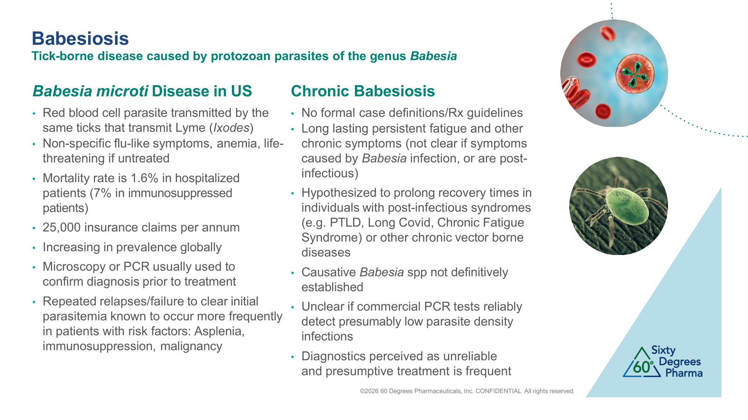
Babesiosis Tick-borne disease caused by protozoan parasites of the genus Babesia Babesia microti Disease in US Chronic Babesiosis • Red blood cell parasite transmitted by the same ticks that transmit Lyme (Ixodes) • Non-specific flu-like symptoms, anemia, life- threatening if untreated • Mortality rate is 1.6% in hospitalized patients (7% in immunosuppressed patients) • 25,000 insurance claims per annum • Increasing in prevalence globally • Microscopy or PCR usually used to confirm diagnosis prior to treatment • Repeated relapses/failure to clear initial parasitemia known to occur more frequently in patients with risk factors: Asplenia, immunosuppression, malignancy • No formal case definitions/Rx guidelines • Long lasting persistent fatigue and other chronic symptoms (not clear if symptoms caused by Babesia infection, or are post- infectious) • Hypothesized to prolong recovery times in individuals with post-infectious syndromes (e.g. PTLD, Long Covid, Chronic Fatigue Syndrome) or other chronic vector borne diseases • Causative Babesia spp not definitively established • Unclear if commercial PCR tests reliably detect presumably low parasite density infections • Diagnostics perceived as unreliable and presumptive treatment is frequent ©2026 60 Degrees Pharmaceuticals, Inc. CONFIDENTIAL All rights reserved.

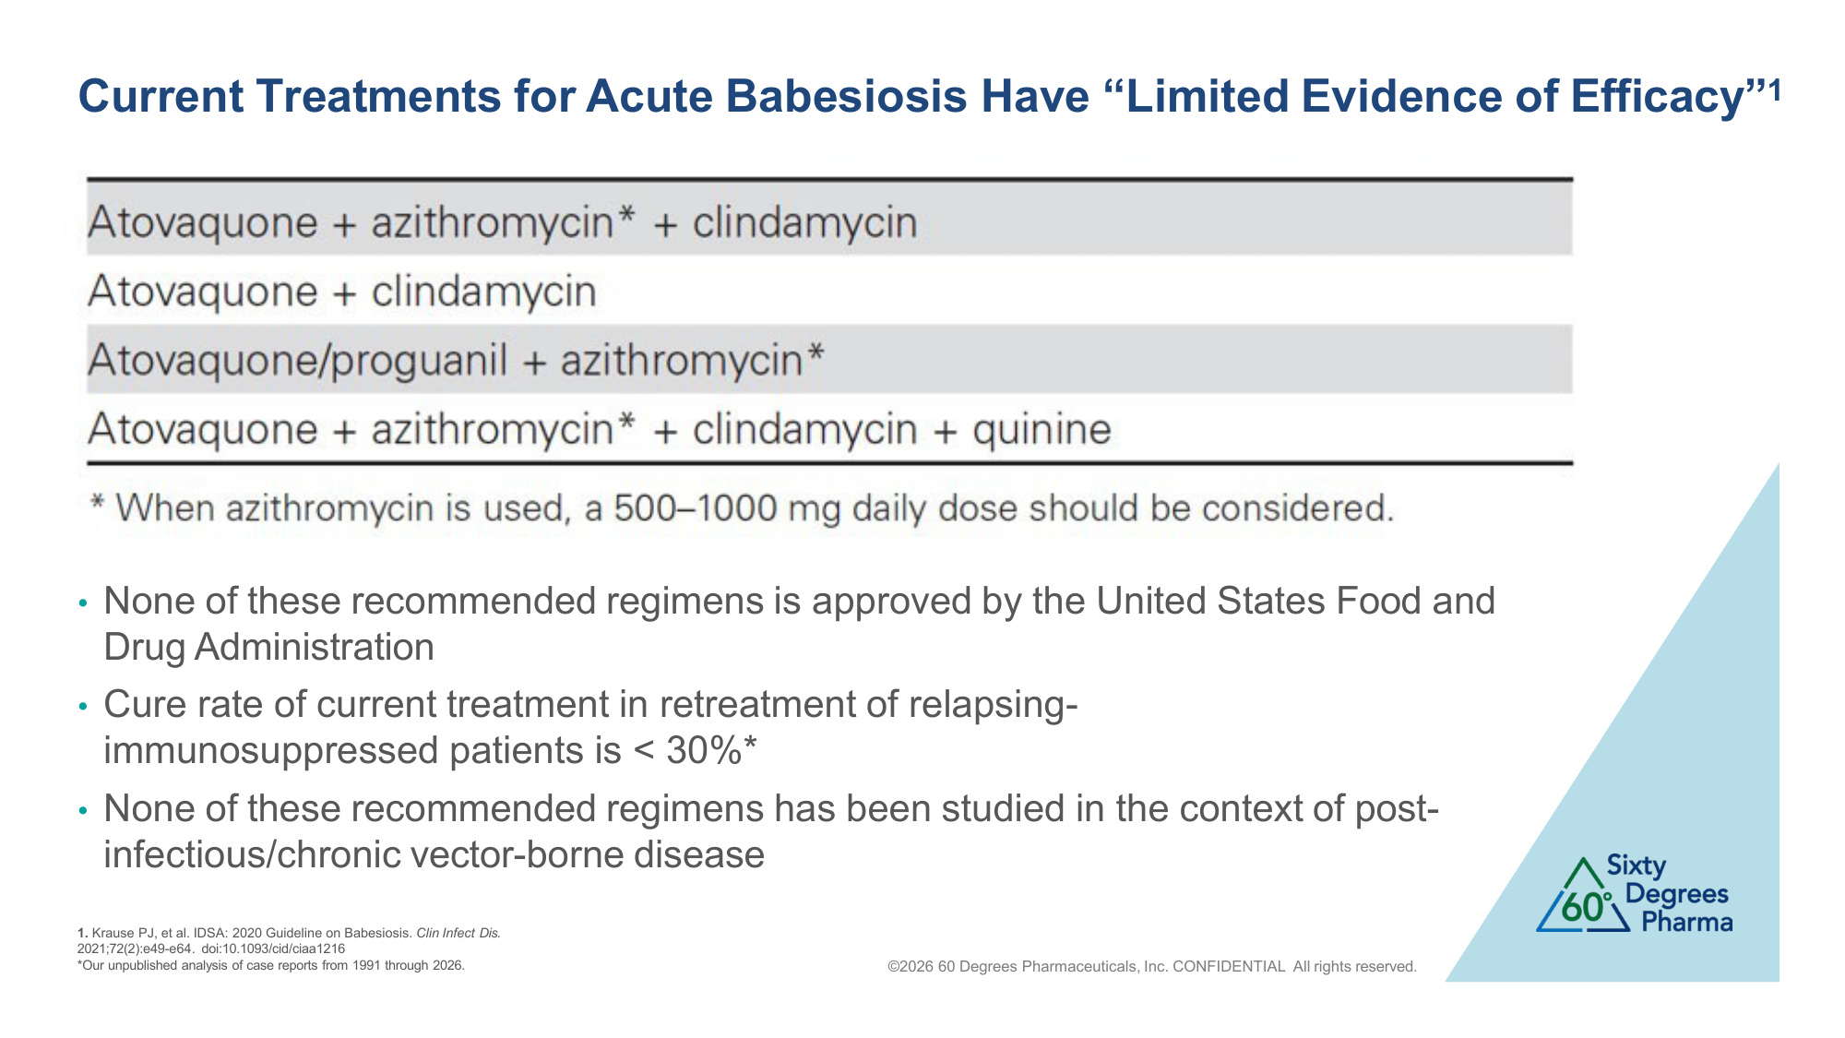
Current Treatments for Acute Babesiosis Have "Limited Evidence of Efficacy"1 • None of these recommended regimens is approved by the United States Food and Drug Administration • Cure rate of current treatment in retreatment of relapsing- immunosuppressed patients is < 30%* • None of these recommended regimens has been studied in the context of post- infectious/chronic vector-borne disease 1. Krause PJ, et al. IDSA: 2020 Guideline on Babesiosis. Clin Infect Dis. 2021;72(2):e49-e64. doi:10.1093/cid/ciaa1216 *Our unpublished analysis of case reports from 1991 through 2026. ©2026 60 Degrees Pharmaceuticals, Inc. CONFIDENTIAL All rights reserved.

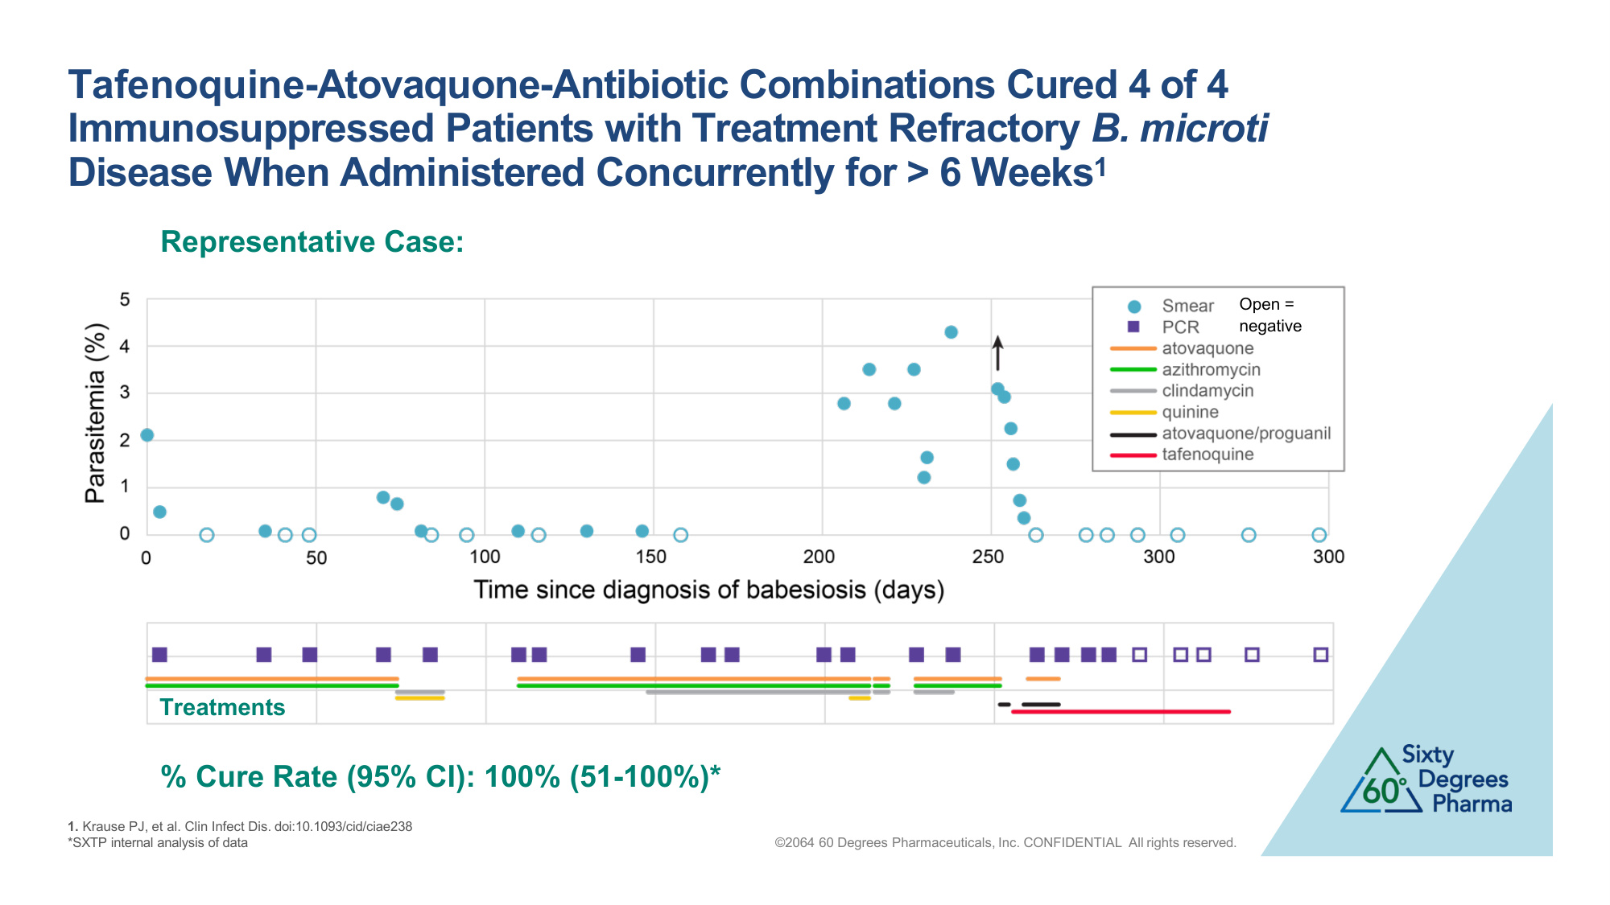
Tafenoquine-Atovaquone-Antibiotic Combinations Cured 4 of 4 Immunosuppressed Patients with Treatment Refractory B. microti Disease When Administered Concurrently for > 6 Weeks1 1. Krause PJ, et al. Clin Infect Dis. doi:10.1093/cid/ciae238 *SXTP internal analysis of data ©2064 60 Degrees Pharmaceuticals, Inc. CONFIDENTIAL All rights reserved. Representative Case: % Cure Rate (95% CI): 100% (51-100%)* Open = negative Treatments

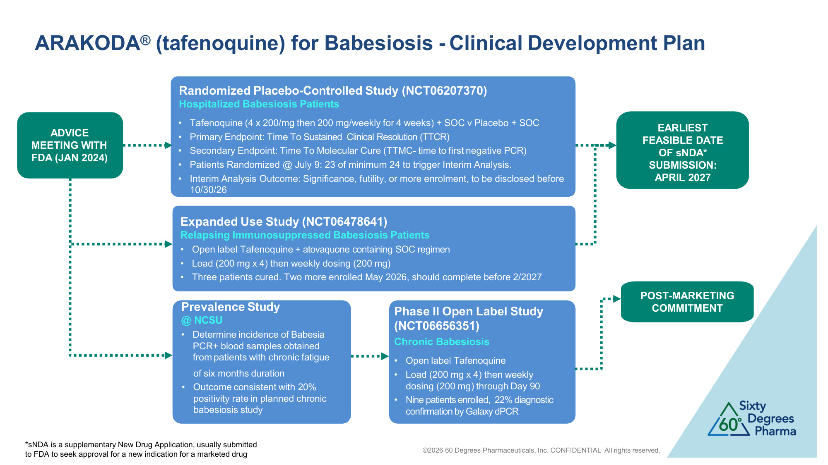
©2026 60 Degrees Pharmaceuticals, Inc. CONFIDENTIAL All rights reserved. ARAKODA® (tafenoquine) for Babesiosis - Clinical Development Plan Randomized Placebo-Controlled Study (NCT06207370) Hospitalized Babesiosis Patients • Tafenoquine (4 x 200/mg then 200 mg/weekly for 4 weeks) + SOC v Placebo + SOC • Primary Endpoint: Time To Sustained Clinical Resolution (TTCR) • Secondary Endpoint: Time To Molecular Cure (TTMC- time to first negative PCR) • Patients Randomized @ July 9: 23 of minimum 24 to trigger Interim Analysis. • Interim Analysis Outcome: Significance, futility, or more enrolment, to be disclosed before 10/30/26 ADVICE MEETING WITH FDA (JAN 2024) EARLIEST FEASIBLE DATE OF sNDA* SUBMISSION: APRIL 2027 Expanded Use Study (NCT06478641) Relapsing Immunosuppressed Babesiosis Patients • Open label Tafenoquine + atovaquone containing SOC regimen • Load (200 mg x 4) then weekly dosing (200 mg) • Three patients cured. Two more enrolled May 2026, should complete before 2/2027 Phase II Open Label Study (NCT06656351) Chronic Babesiosis • Open label Tafenoquine • Load (200 mg x 4) then weekly dosing (200 mg) through Day 90 • Nine patients enrolled, 22% diagnostic confirmation by Galaxy dPCR Prevalence Study @ NCSU • Determine incidence of Babesia PCR+ blood samples obtained from patients with chronic fatigue of six months duration • Outcome consistent with 20% positivity rate in planned chronic babesiosis study POST-MARKETING COMMITMENT *sNDA is a supplementary New Drug Application, usually submitted to FDA to seek approval for a new indication for a marketed drug

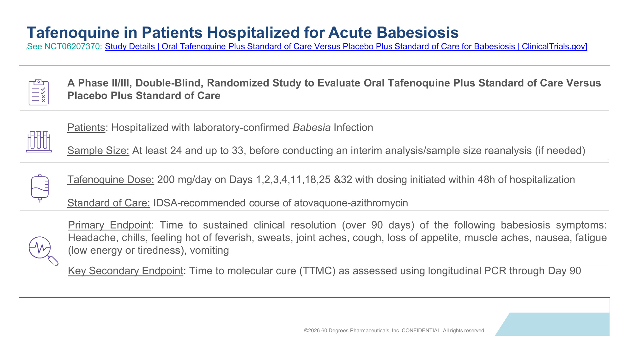
Tafenoquine in Patients Hospitalized for Acute Babesiosis [See NCT06207370: Study Details | Oral Tafenoquine Plus Standard of Care Versus Placebo Plus Standard of Care for Babesiosis | ClinicalTrials.gov] A Phase II/III, Double-Blind, Randomized Study to Evaluate Oral Tafenoquine Plus Standard of Care Versus Placebo Plus Standard of Care Patients: Hospitalized with laboratory-confirmed Babesia Infection Sample Size: At least 24 and up to 33, before conducting an interim analysis/sample size reanalysis (if needed) Tafenoquine Dose: 200 mg/day on Days 1,2,3,4,11,18,25 &32 with dosing initiated within 48h of hospitalization Standard of Care: IDSA-recommended course of atovaquone-azithromycin Primary Endpoint: Time to sustained clinical resolution (over 90 days) of the following babesiosis symptoms: Headache, chills, feeling hot of feverish, sweats, joint aches, cough, loss of appetite, muscle aches, nausea, fatigue (low energy or tiredness), vomiting Key Secondary Endpoint: Time to molecular cure (TTMC) as assessed using longitudinal PCR through Day 90 ©2026 60 Degrees Pharmaceuticals, Inc. CONFIDENTIAL All rights reserved.

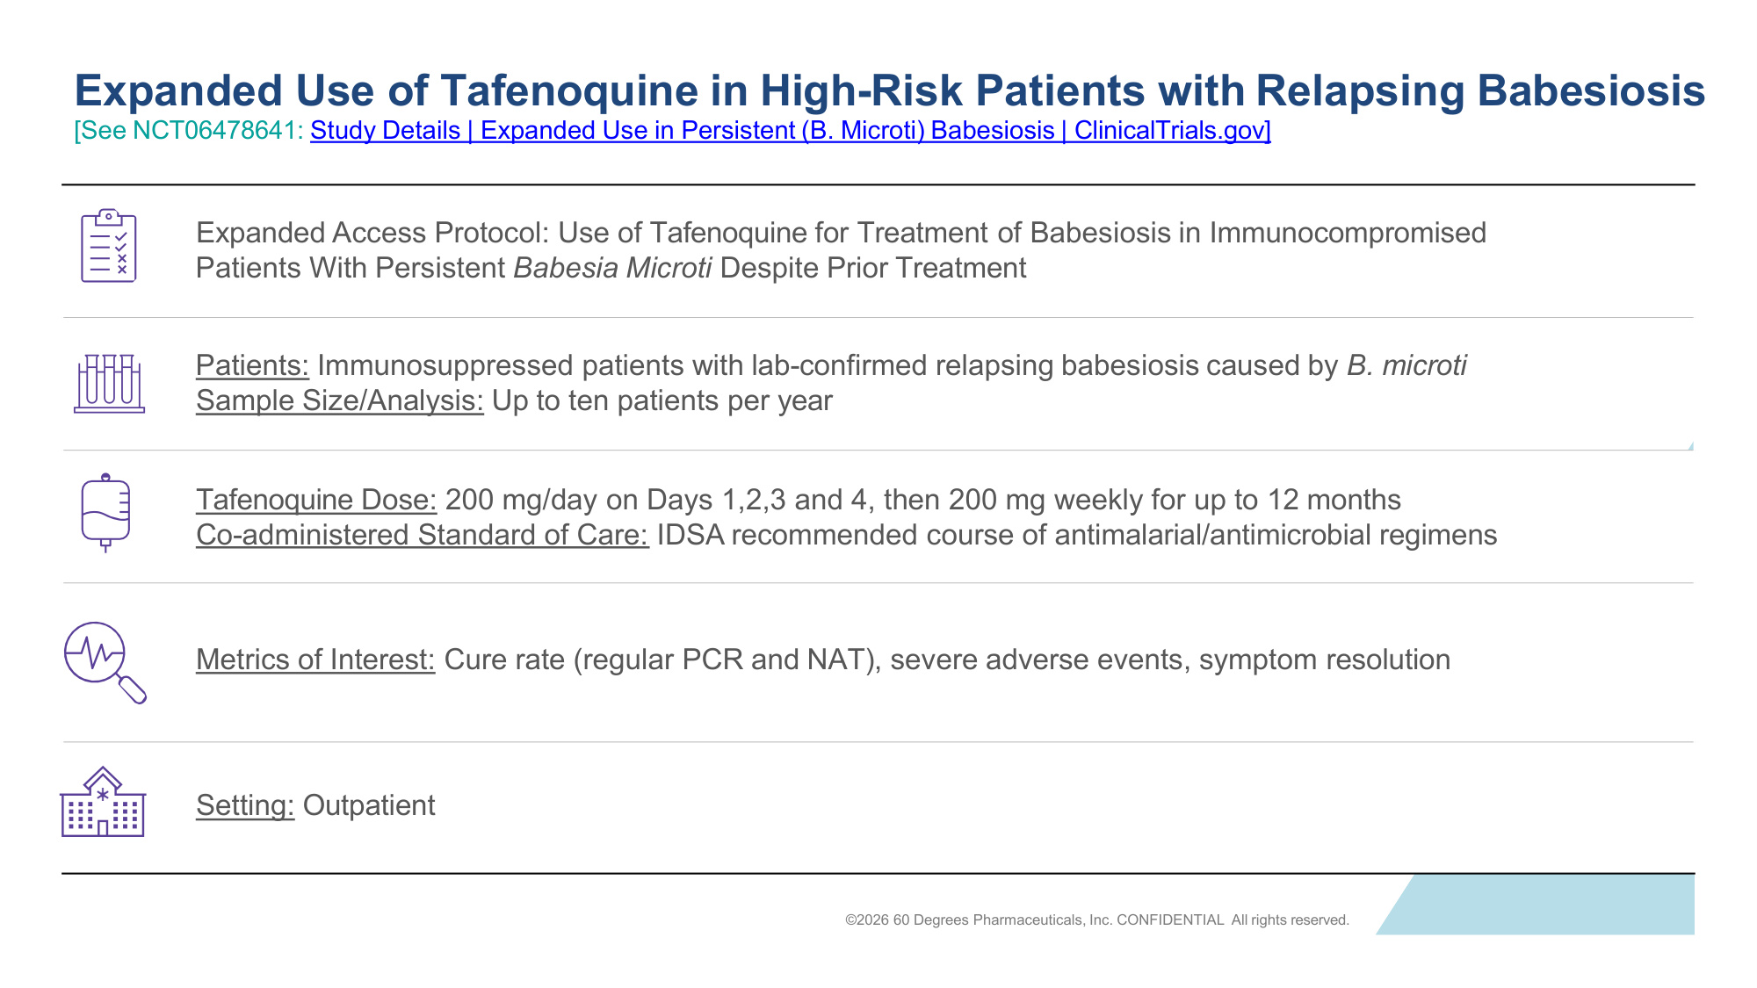
Expanded Use of Tafenoquine in High-Risk Patients with Relapsing Babesiosis [See NCT06478641: Study Details | Expanded Use in Persistent (B. Microti) Babesiosis | ClinicalTrials.gov] Expanded Access Protocol: Use of Tafenoquine for Treatment of Babesiosis in Immunocompromised Patients With Persistent Babesia Microti Despite Prior Treatment Patients: Immunosuppressed patients with lab-confirmed relapsing babesiosis caused by B. microti Sample Size/Analysis: Up to ten patients per year Tafenoquine Dose: 200 mg/day on Days 1,2,3 and 4, then 200 mg weekly for up to 12 months Co-administered Standard of Care: IDSA recommended course of antimalarial/antimicrobial regimens Metrics of Interest: Cure rate (regular PCR and NAT), severe adverse events, symptom resolution Setting: Outpatient ©2026 60 Degrees Pharmaceuticals, Inc. CONFIDENTIAL All rights reserved.

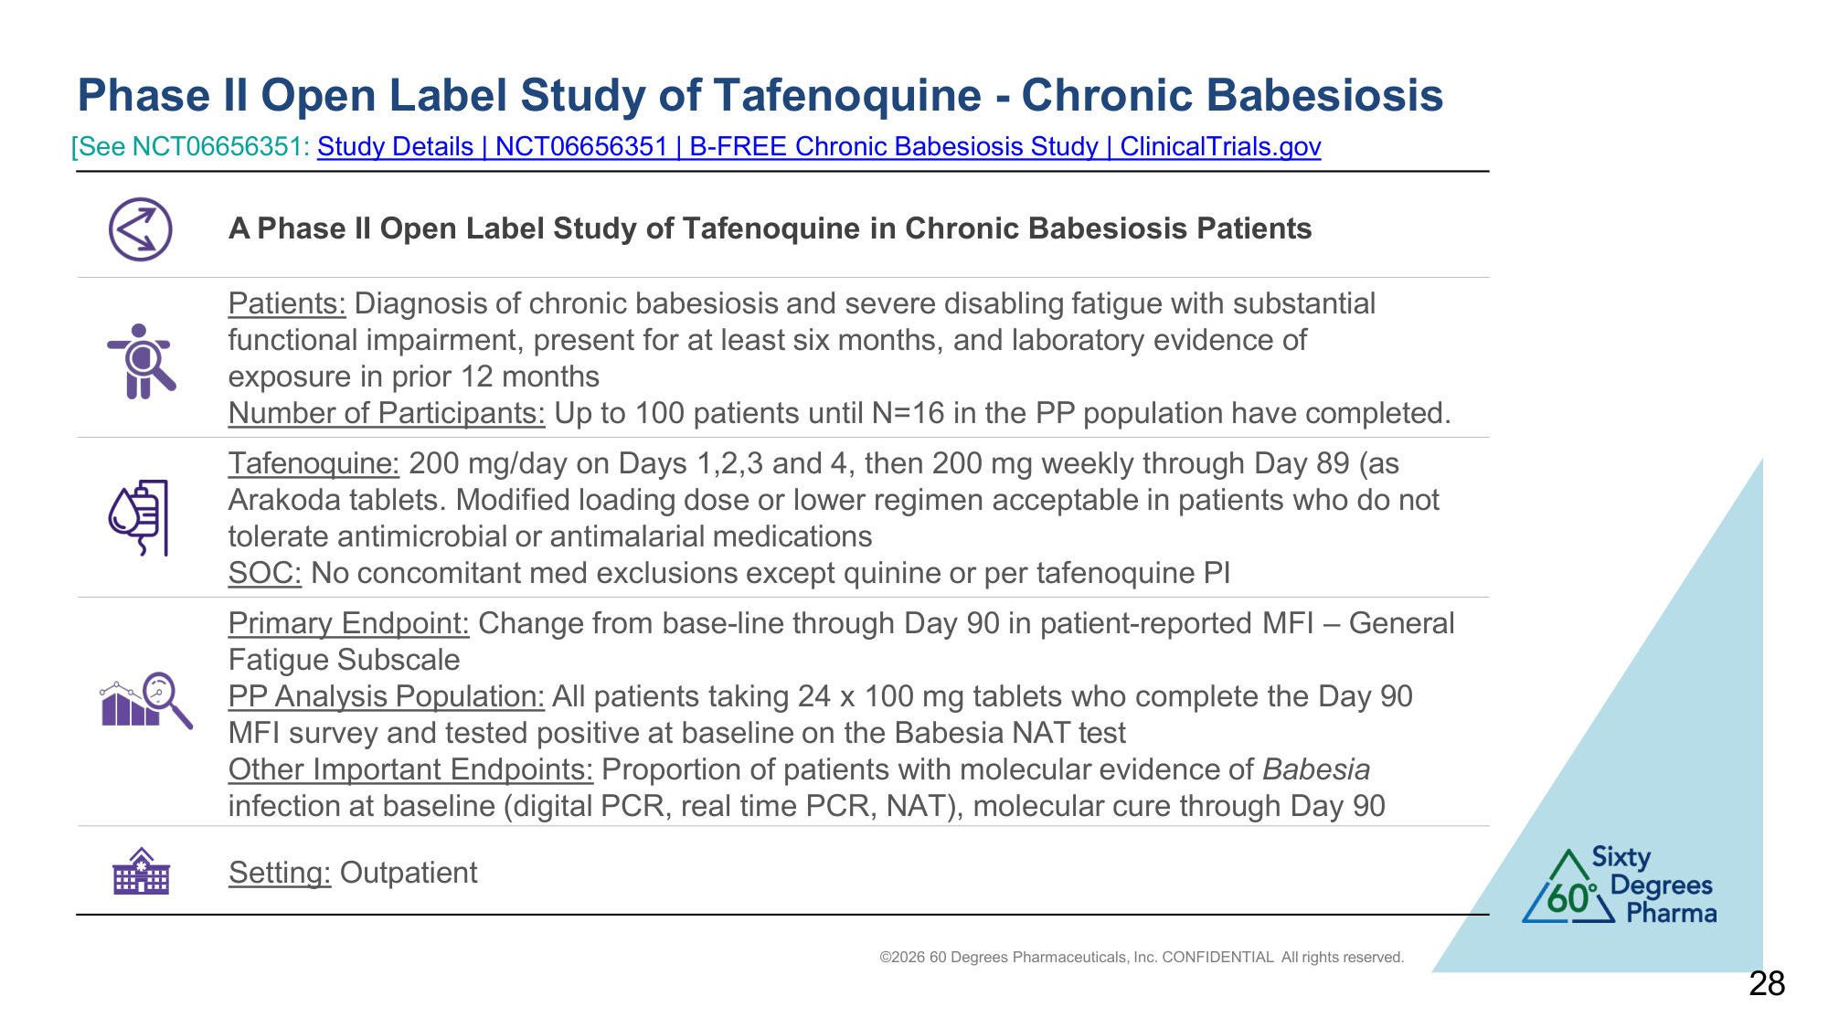
©2026 60 Degrees Pharmaceuticals, Inc. CONFIDENTIAL All rights reserved. Phase II Open Label Study of Tafenoquine - Chronic Babesiosis 28 A Phase II Open Label Study of Tafenoquine in Chronic Babesiosis Patients Patients: Diagnosis of chronic babesiosis and severe disabling fatigue with substantial functional impairment, present for at least six months, and laboratory evidence of exposure in prior 12 months Number of Participants: Up to 100 patients until N=16 in the PP population have completed. Tafenoquine: 200 mg/day on Days 1,2,3 and 4, then 200 mg weekly through Day 89 (as Arakoda tablets. Modified loading dose or lower regimen acceptable in patients who do not tolerate antimicrobial or antimalarial medications SOC: No concomitant med exclusions except quinine or per tafenoquine PI Primary Endpoint: Change from base-line through Day 90 in patient-reported MFI – General Fatigue Subscale PP Analysis Population: All patients taking 24 x 100 mg tablets who complete the Day 90 MFI survey and tested positive at baseline on the Babesia NAT test Other Important Endpoints: Proportion of patients with molecular evidence of Babesia infection at baseline (digital PCR, real time PCR, NAT), molecular cure through Day 90 Setting: Outpatient [See NCT06656351: Study Details | NCT06656351 | B-FREE Chronic Babesiosis Study | ClinicalTrials.gov

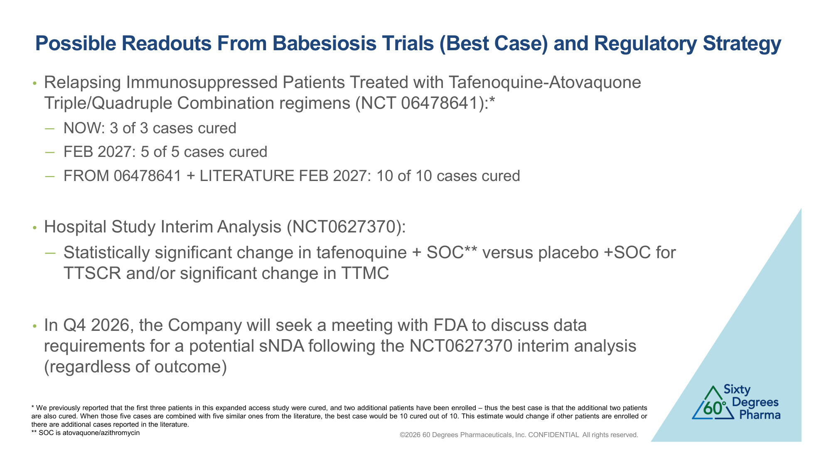
Possible Readouts From Babesiosis Trials (Best Case) and Regulatory Strategy ©2026 60 Degrees Pharmaceuticals, Inc. CONFIDENTIAL All rights reserved. • Relapsing Immunosuppressed Patients Treated with Tafenoquine-Atovaquone Triple/Quadruple Combination regimens (NCT 06478641):* −NOW: 3 of 3 cases cured −FEB 2027: 5 of 5 cases cured −FROM 06478641 + LITERATURE FEB 2027: 10 of 10 cases cured • Hospital Study Interim Analysis (NCT0627370): −Statistically significant change in tafenoquine + SOC** versus placebo +SOC for TTSCR and/or significant change in TTMC • In Q4 2026, the Company will seek a meeting with FDA to discuss data requirements for a potential sNDA following the NCT0627370 interim analysis (regardless of outcome) * We previously reported that the first three patients in this expanded access study were cured, and two additional patients have been enrolled – thus the best case is that the additional two patients are also cured. When those five cases are combined with five similar ones from the literature, the best case would be 10 cured out of 10. This estimate would change if other patients are enrolled or there are additional cases reported in the literature. ** SOC is atovaquone/azithromycin

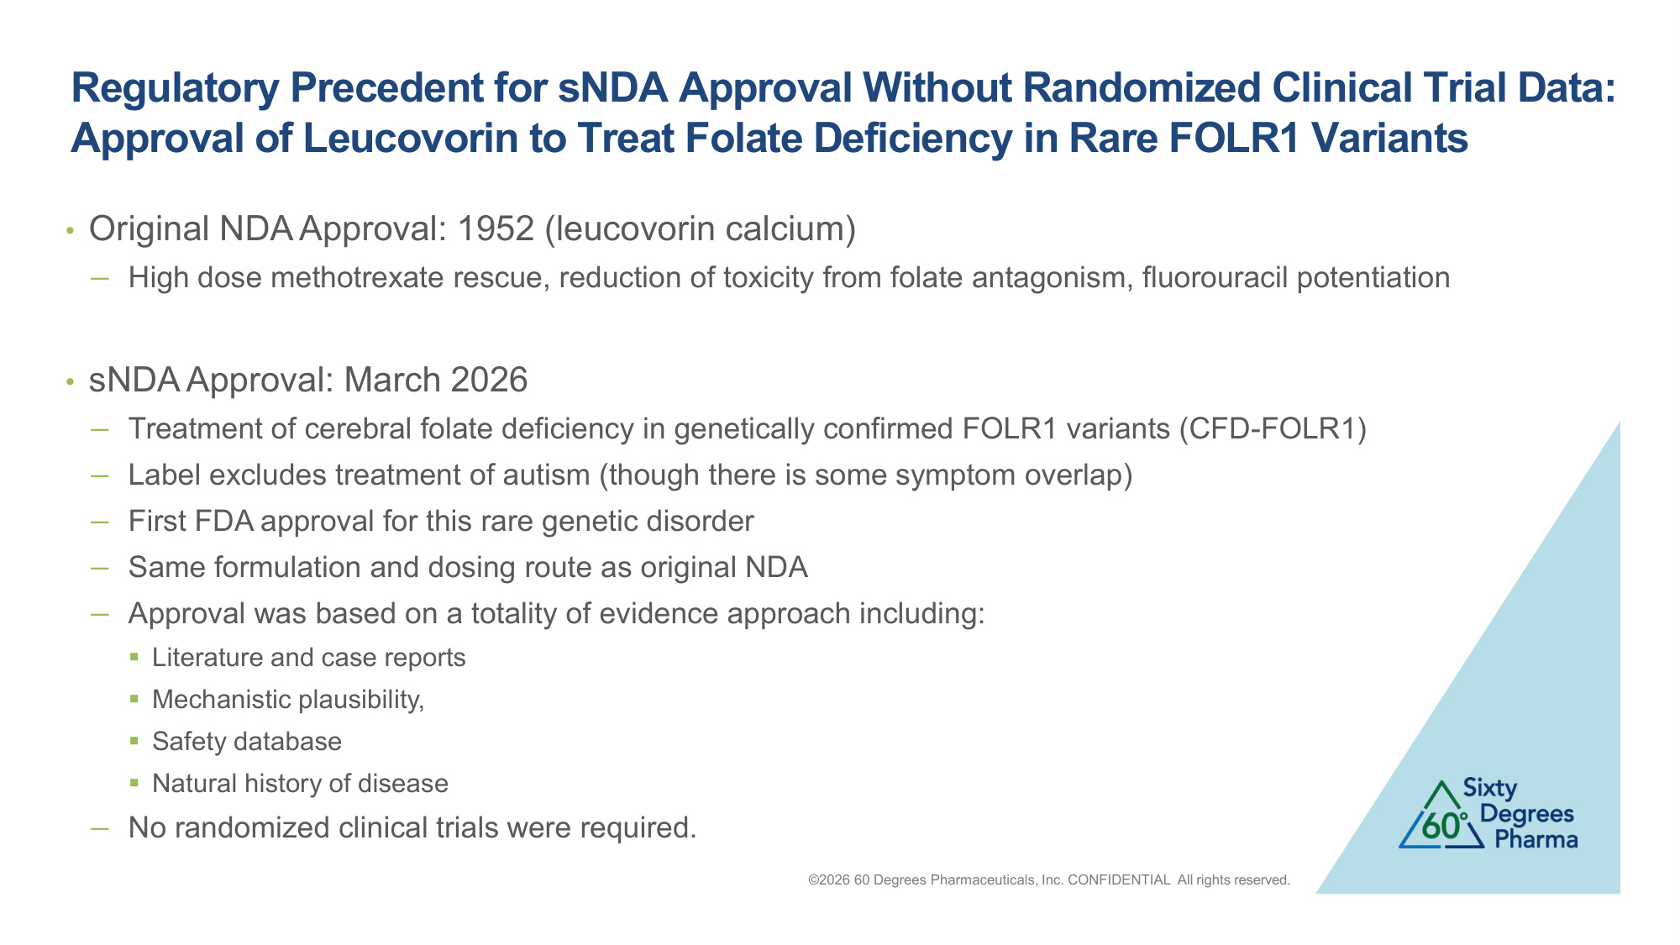
Regulatory Precedent for sNDA Approval Without Randomized Clinical Trial Data: Approval of Leucovorin to Treat Folate Deficiency in Rare FOLR1 Variants ©2026 60 Degrees Pharmaceuticals, Inc. CONFIDENTIAL All rights reserved. • Original NDA Approval: 1952 (leucovorin calcium) −High dose methotrexate rescue, reduction of toxicity from folate antagonism, fluorouracil potentiation • sNDA Approval: March 2026 −Treatment of cerebral folate deficiency in genetically confirmed FOLR1 variants (CFD-FOLR1) −Label excludes treatment of autism (though there is some symptom overlap) −First FDA approval for this rare genetic disorder −Same formulation and dosing route as original NDA −Approval was based on a totality of evidence approach including: ▪Literature and case reports ▪Mechanistic plausibility, ▪Safety database ▪Natural history of disease −No randomized clinical trials were required.

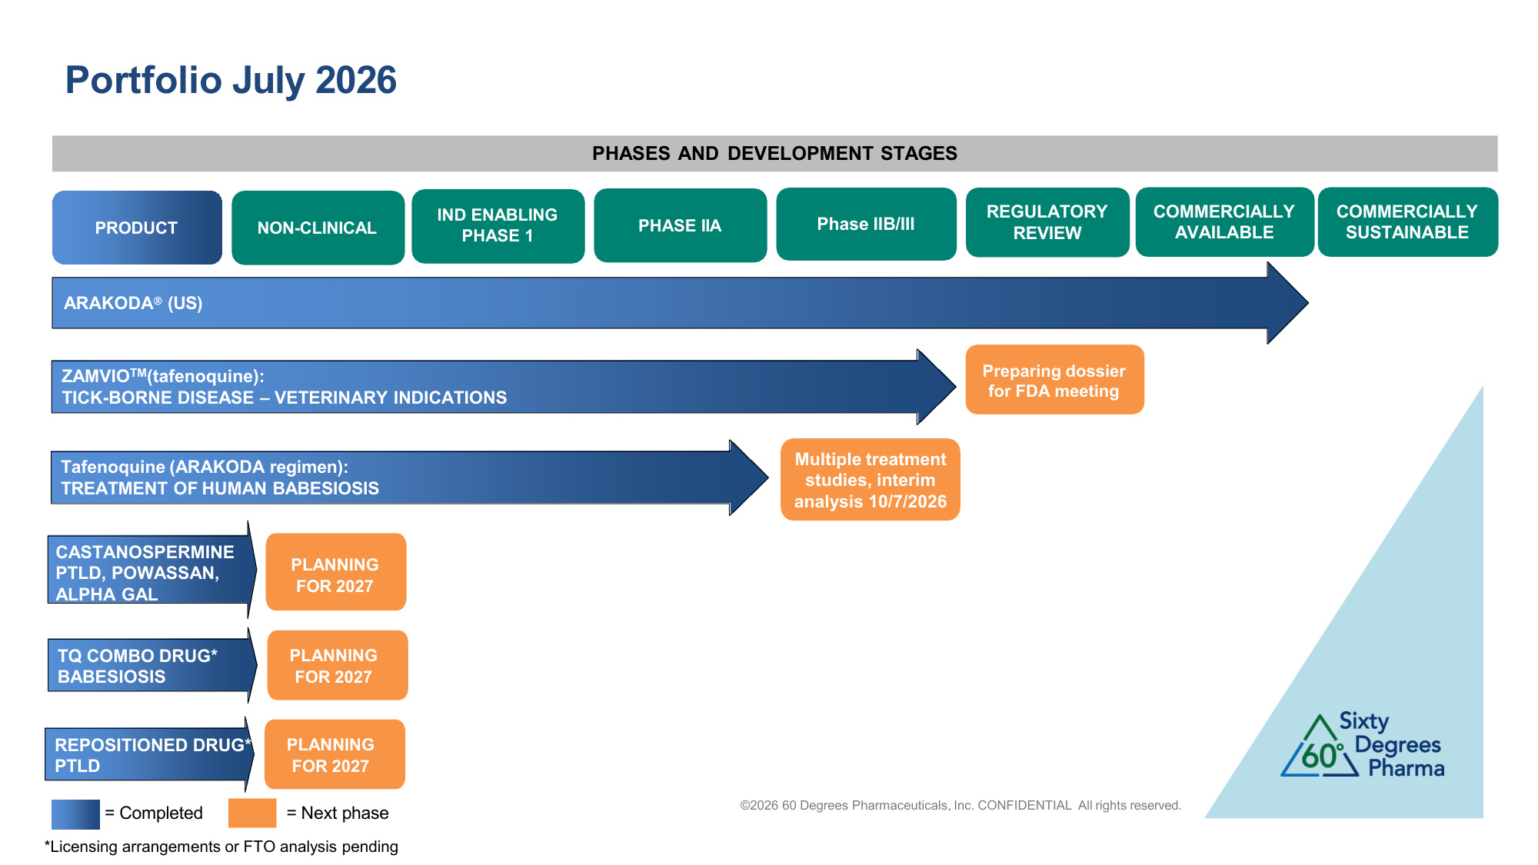
©2026 60 Degrees Pharmaceuticals, Inc. CONFIDENTIAL All rights reserved. Executing 3 trials. Targeting completion in 2026 Portfolio July 2026 IND ENABLING PHASE 1 PHASE IIA Phase IIB/III REGULATORY REVIEW = Completed PHASES AND DEVELOPMENT STAGES COMMERCIALLY AVAILABLE ARAKODA (US) Tafenoquine (ARAKODA regimen): TREATMENT OF HUMAN BABESIOSIS NON-CLINICAL COMMERCIALLY SUSTAINABLE PRODUCT ZAMVIOTM(tafenoquine): TICK-BORNE DISEASE – VETERINARY INDICATIONS Preparing dossier for FDA meeting Multiple treatment studies, interim analysis 10/7/2026 = Next phase CASTANOSPERMINE PTLD, POWASSAN, ALPHA GAL PLANNING FOR 2027 TQ COMBO DRUG* BABESIOSIS PLANNING FOR 2027 REPOSITIONED DRUG* PTLD PLANNING FOR 2027 *Licensing arrangements or FTO analysis pending

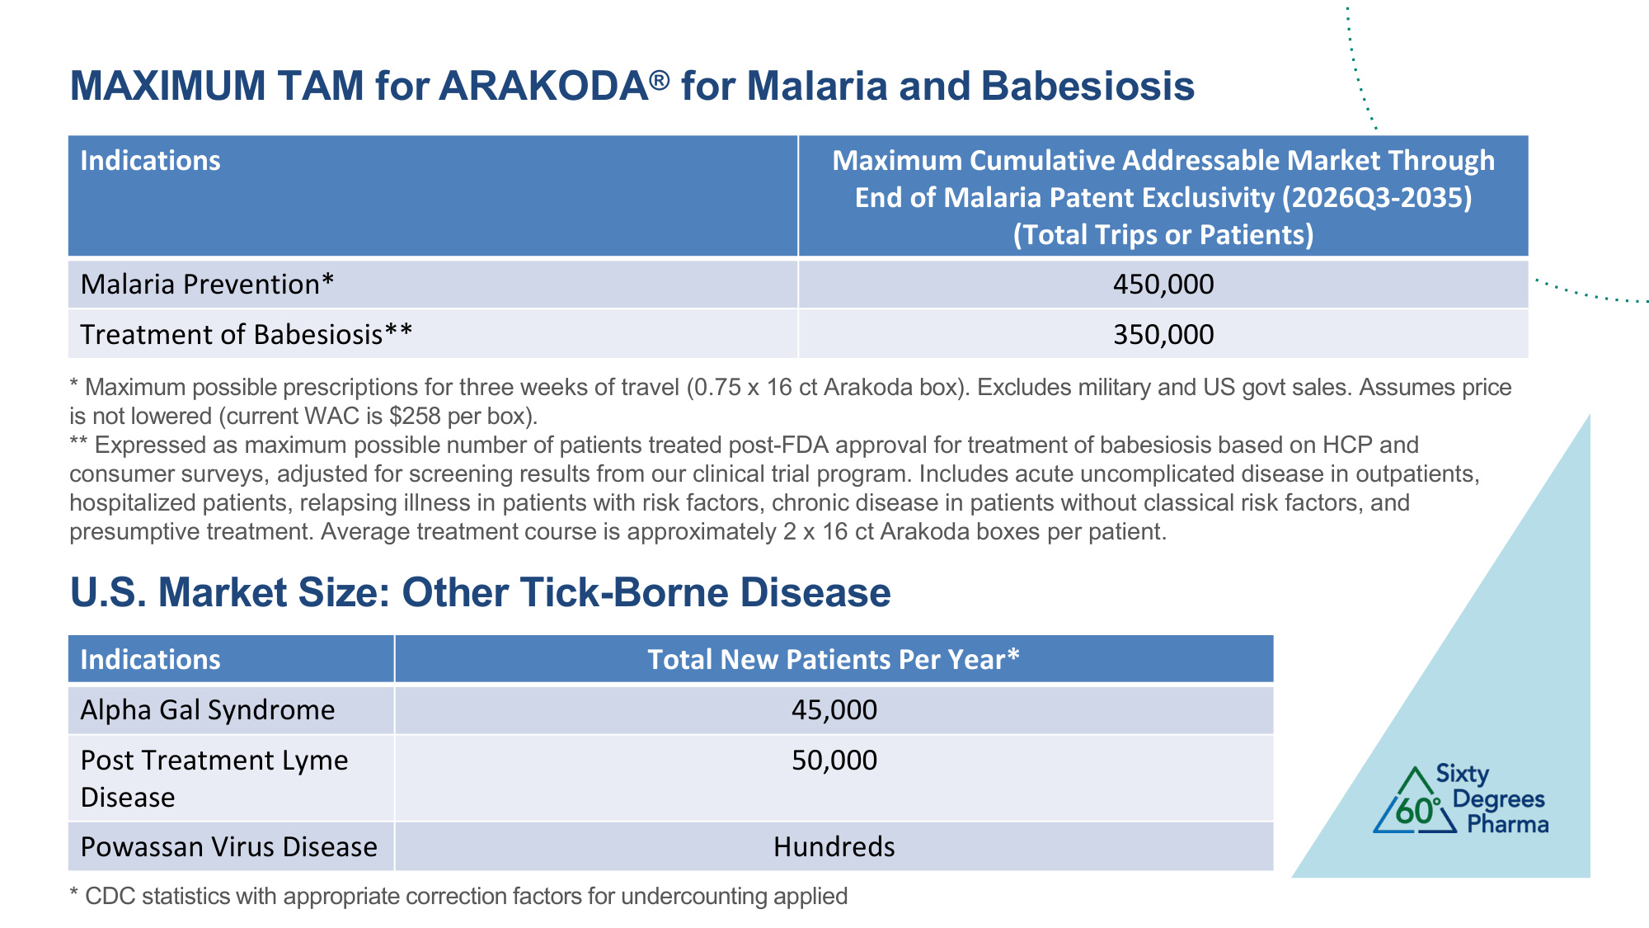
MAXIMUM TAM for ARAKODA® for Malaria and Babesiosis ©2026 60 Degrees Pharmaceuticals, Inc. CONFIDENTIAL All rights reserved. * Maximum possible prescriptions for three weeks of travel (0.75 x 16 ct Arakoda box). Excludes military and US govt sales. Assumes price is not lowered (current WAC is $258 per box). ** Expressed as maximum possible number of patients treated post-FDA approval for treatment of babesiosis based on HCP and consumer surveys, adjusted for screening results from our clinical trial program. Includes acute uncomplicated disease in outpatients, hospitalized patients, relapsing illness in patients with risk factors, chronic disease in patients without classical risk factors, and presumptive treatment. Average treatment course is approximately 2 x 16 ct Arakoda boxes per patient. Indications Maximum Cumulative Addressable Market Through End of Malaria Patent Exclusivity (2026Q3-2035) (Total Trips or Patients) Malaria Prevention* 450,000 Treatment of Babesiosis** 350,000 Indications Total New Patients Per Year* Alpha Gal Syndrome 45,000 Post Treatment Lyme Disease 50,000 Powassan Virus Disease Hundreds U.S. Market Size: Other Tick-Borne Disease * CDC statistics with appropriate correction factors for undercounting applied

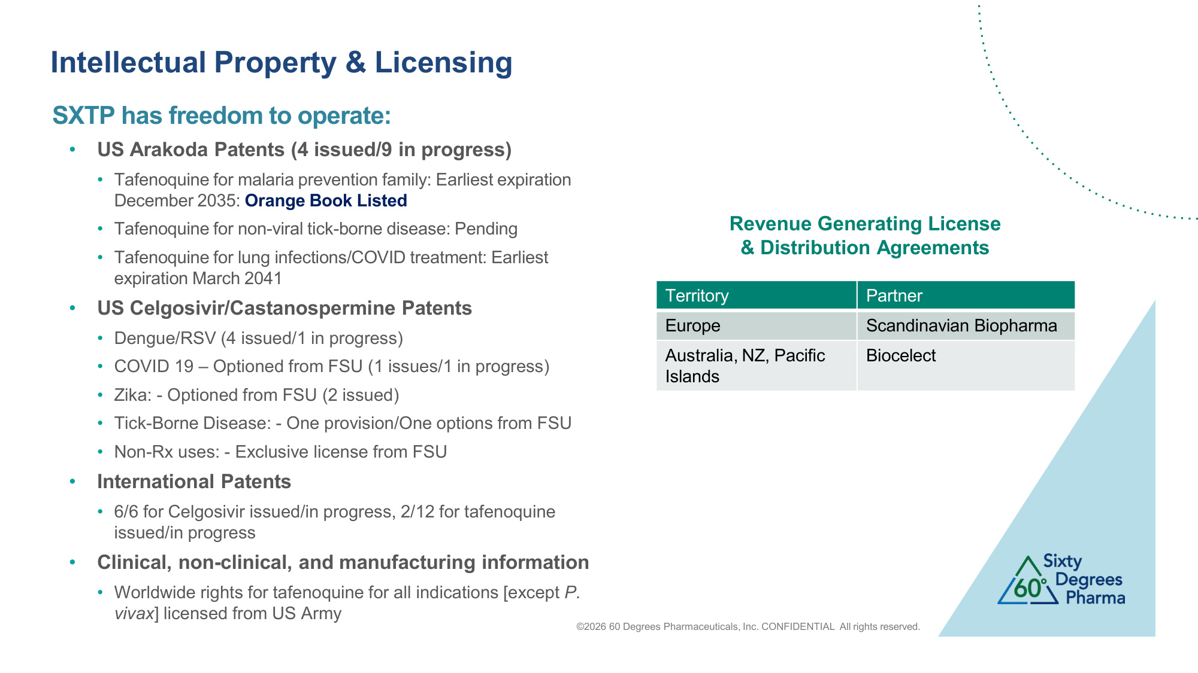
Intellectual Property & Licensing ©2026 60 Degrees Pharmaceuticals, Inc. CONFIDENTIAL All rights reserved. Territory Partner Europe Scandinavian Biopharma Australia, NZ, Pacific Islands Biocelect Revenue Generating License & Distribution Agreements SXTP has freedom to operate: • US Arakoda Patents (4 issued/9 in progress) • Tafenoquine for malaria prevention family: Earliest expiration December 2035: Orange Book Listed • Tafenoquine for non-viral tick-borne disease: Pending • Tafenoquine for lung infections/COVID treatment: Earliest expiration March 2041 • US Celgosivir/Castanospermine Patents • Dengue/RSV (4 issued/1 in progress) • COVID 19 – Optioned from FSU (1 issues/1 in progress) • Zika: - Optioned from FSU (2 issued) • Tick-Borne Disease: - One provision/One options from FSU • Non-Rx uses: - Exclusive license from FSU • International Patents • 6/6 for Celgosivir issued/in progress, 2/12 for tafenoquine issued/in progress • Clinical, non-clinical, and manufacturing information • Worldwide rights for tafenoquine for all indications [except P. vivax] licensed from US Army

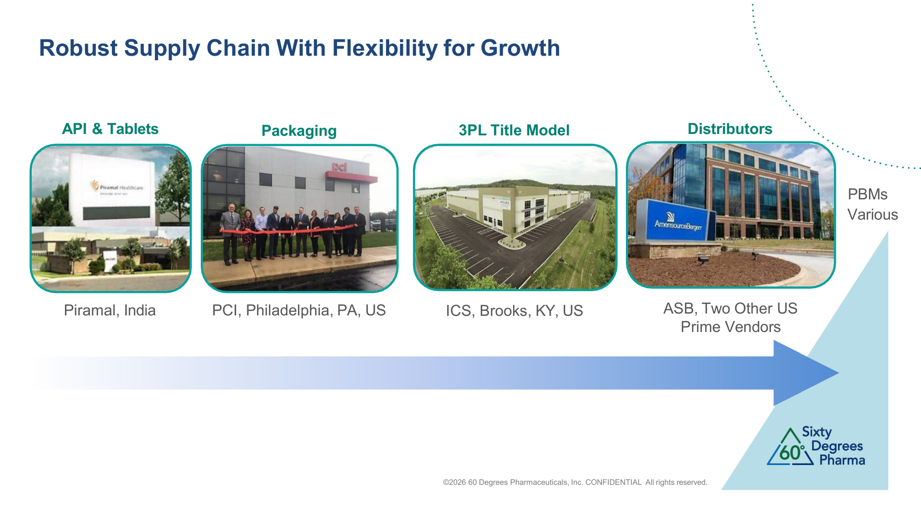
Robust Supply Chain With Flexibility for Growth API & Tablets Piramal, India Packaging PCI, Philadelphia, PA, US Distributors ICS, Brooks, KY, US 3PL Title Model ASB, Two Other US Prime Vendors PBMs Various ©2026 60 Degrees Pharmaceuticals, Inc. CONFIDENTIAL All rights reserved.

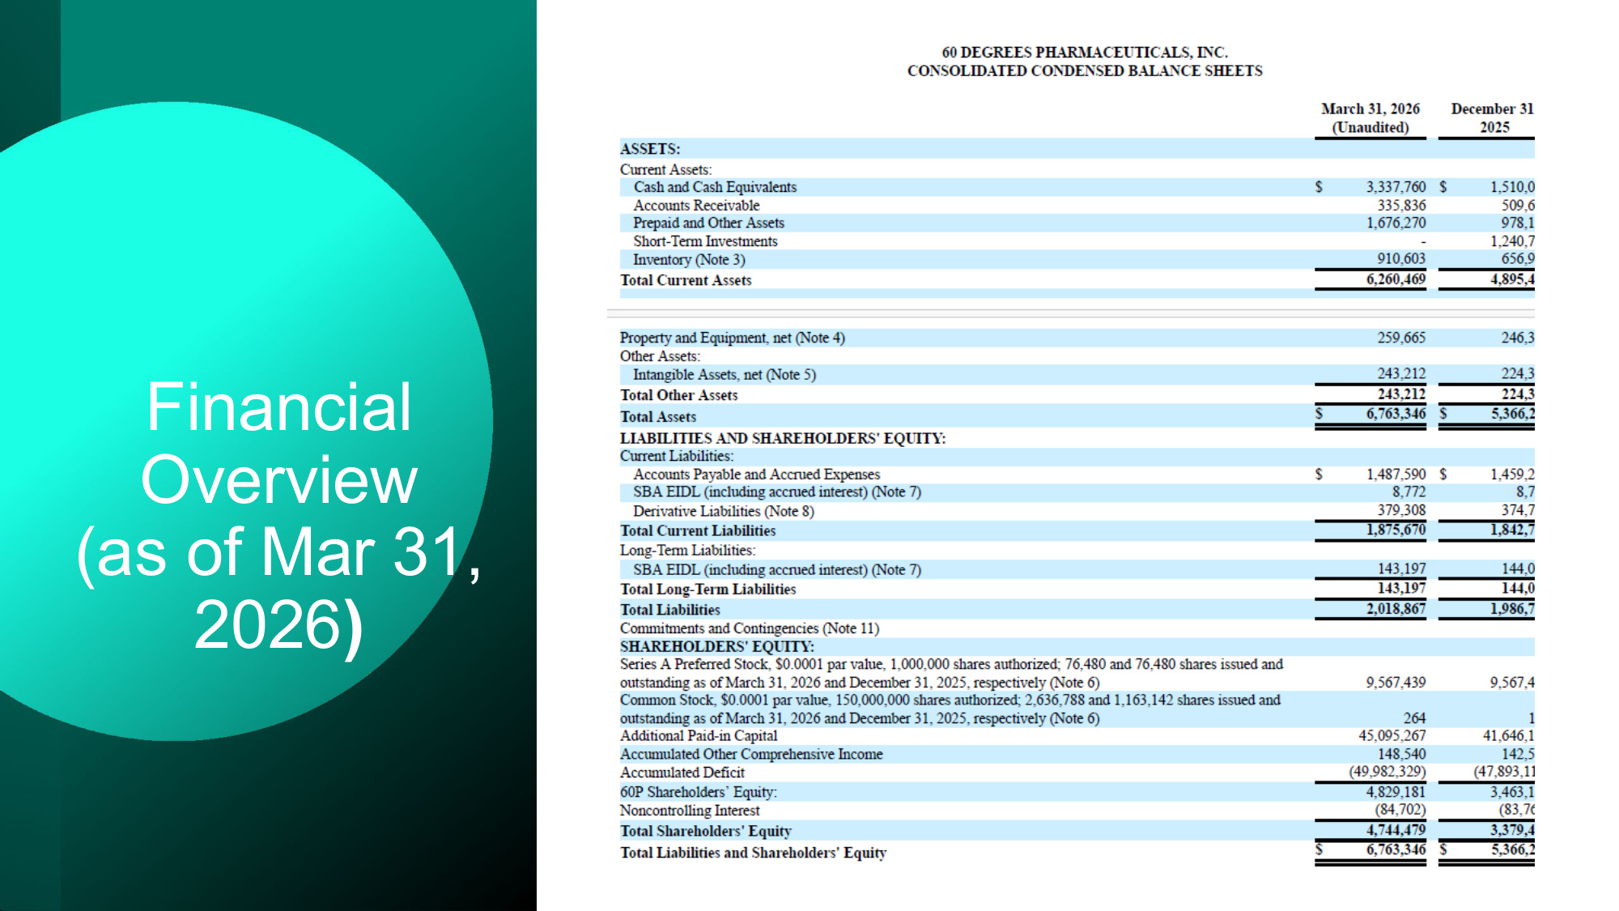
Financial Overview (as of Mar 31, 2026)

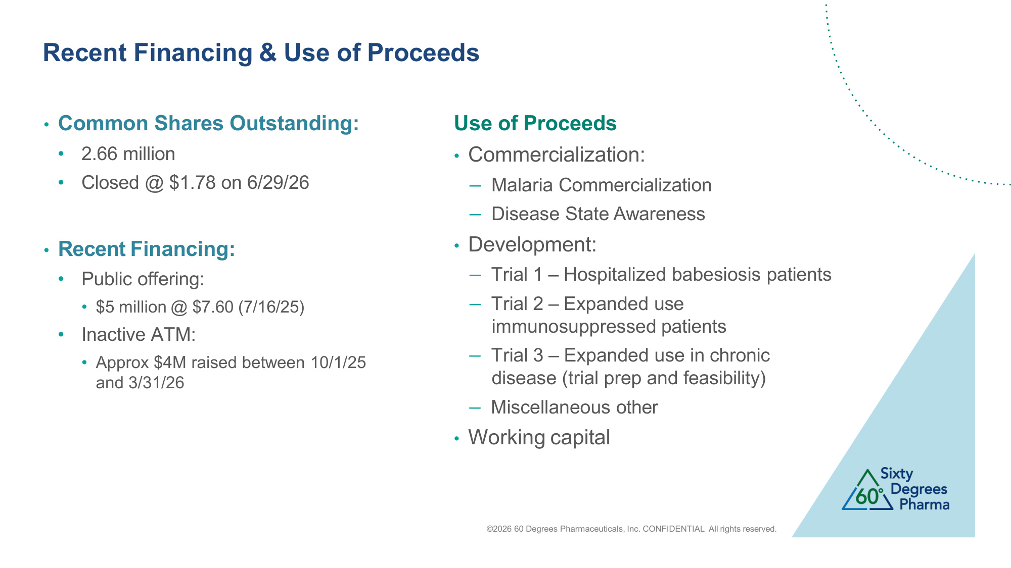
Recent Financing & Use of Proceeds ©2026 60 Degrees Pharmaceuticals, Inc. CONFIDENTIAL All rights reserved. • Common Shares Outstanding: • 2.66 million • Closed @ $1.78 on 6/29/26 • Recent Financing: • Public offering: • $5 million @ $7.60 (7/16/25) • Inactive ATM: • Approx $4M raised between 10/1/25 and 3/31/26 Use of Proceeds • Commercialization: − Malaria Commercialization − Disease State Awareness • Development: − Trial 1 – Hospitalized babesiosis patients − Trial 2 – Expanded use immunosuppressed patients − Trial 3 – Expanded use in chronic disease (trial prep and feasibility) − Miscellaneous other • Working capital

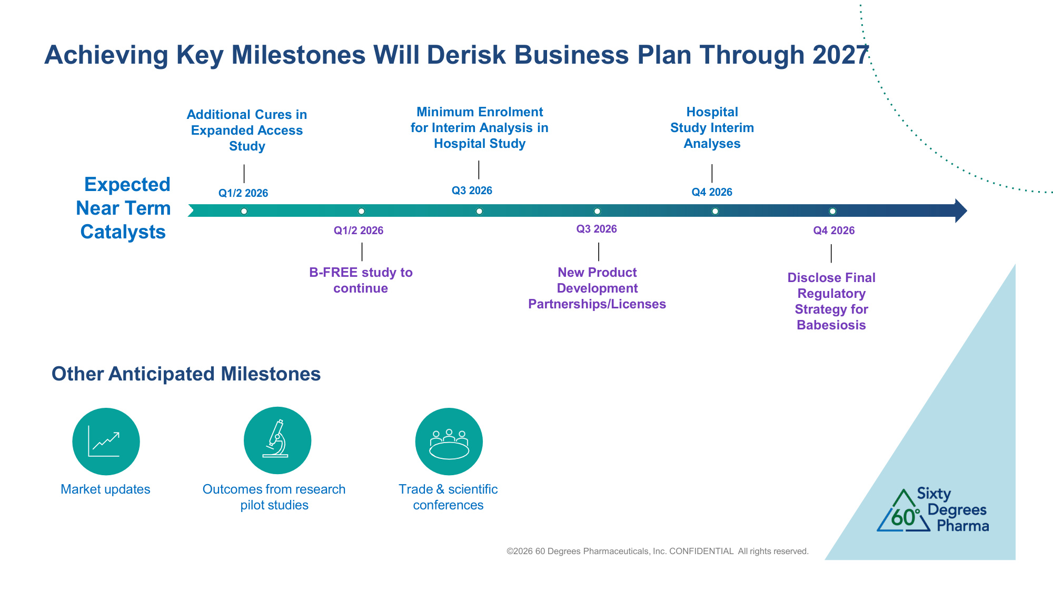
Achieving Key Milestones Will Derisk Business Plan Through 2027 Q1/2 2026 Q1/2 2026 Q3 2026 Q3 2026 Q4 2026 Q4 2026 New Product Development Partnerships/Licenses B-FREE study to continue Minimum Enrolment for Interim Analysis in Hospital Study Hospital Study Interim Analyses Disclose Final Regulatory Strategy for Babesiosis Expected Near Term Catalysts Other Anticipated Milestones Outcomes from research pilot studies ©2026 60 Degrees Pharmaceuticals, Inc. CONFIDENTIAL All rights reserved. Market updates Trade & scientific conferences Additional Cures in Expanded Access Study

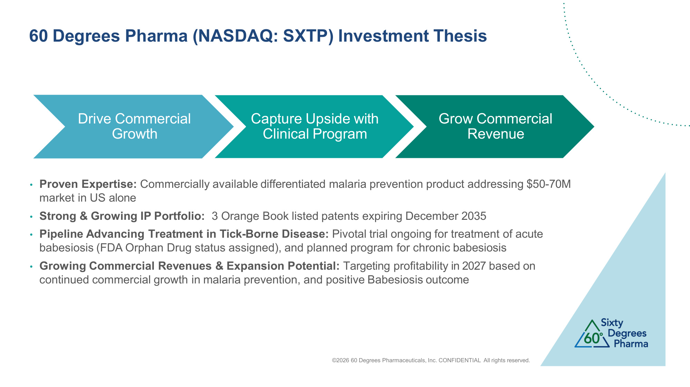
60 Degrees Pharma (NASDAQ: SXTP) Investment Thesis • Proven Expertise: Commercially available differentiated malaria prevention product addressing $50-70M market in US alone • Strong & Growing IP Portfolio: 3 Orange Book listed patents expiring December 2035 • Pipeline Advancing Treatment in Tick-Borne Disease: Pivotal trial ongoing for treatment of acute babesiosis (FDA Orphan Drug status assigned), and planned program for chronic babesiosis • Growing Commercial Revenues & Expansion Potential: Targeting profitability in 2027 based on continued commercial growth in malaria prevention, and positive Babesiosis outcome Drive Commercial Growth Capture Upside with Clinical Program Grow Commercial Revenue ©2026 60 Degrees Pharmaceuticals, Inc. CONFIDENTIAL All rights reserved.

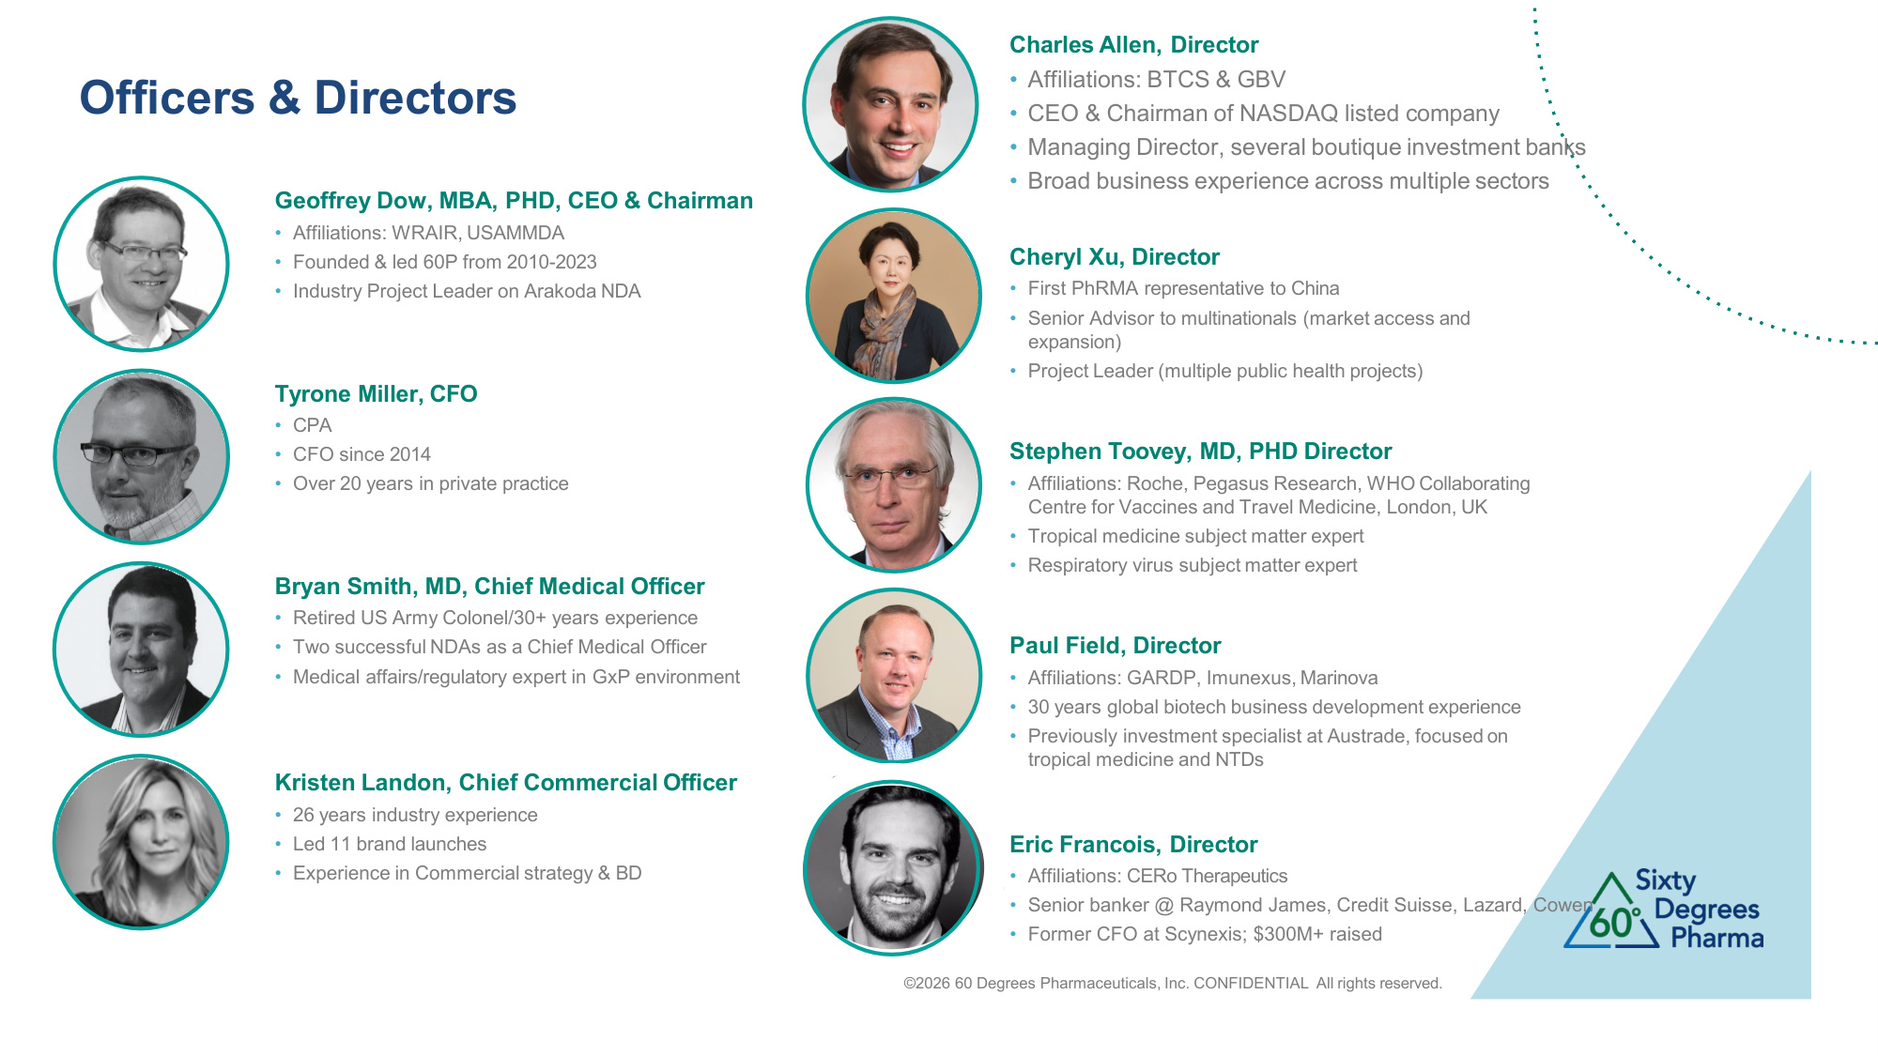
Officers & Directors Geoffrey Dow, MBA, PHD, CEO & Chairman • Affiliations: WRAIR, USAMMDA • Founded & led 60P from 2010-2023 • Industry Project Leader on Arakoda NDA ©2026 60 Degrees Pharmaceuticals, Inc. CONFIDENTIAL All rights reserved. Tyrone Miller, CFO • CPA • CFO since 2014 • Over 20 years in private practice Bryan Smith, MD, Chief Medical Officer • Retired US Army Colonel/30+ years experience • Two successful NDAs as a Chief Medical Officer • Medical affairs/regulatory expert in GxP environment Kristen Landon, Chief Commercial Officer • 26 years industry experience • Led 11 brand launches • Experience in Commercial strategy & BD Charles Allen, Director • Affiliations: BTCS & GBV • CEO & Chairman of NASDAQ listed company • Managing Director, several boutique investment banks • Broad business experience across multiple sectors Cheryl Xu, Director • First PhRMA representative to China • Senior Advisor to multinationals (market access and expansion) • Project Leader (multiple public health projects) Stephen Toovey, MD, PHD Director • Affiliations: Roche, Pegasus Research, WHO Collaborating Centre for Vaccines and Travel Medicine, London, UK • Tropical medicine subject matter expert • Respiratory virus subject matter expert Paul Field, Director • Affiliations: GARDP, Imunexus, Marinova • 30 years global biotech business development experience • Previously investment specialist at Austrade, focused on tropical medicine and NTDs Eric Francois, Director • Affiliations: CERo Therapeutics • Senior banker @ Raymond James, Credit Suisse, Lazard, Cowen • Former CFO at Scynexis; $300M+ raised

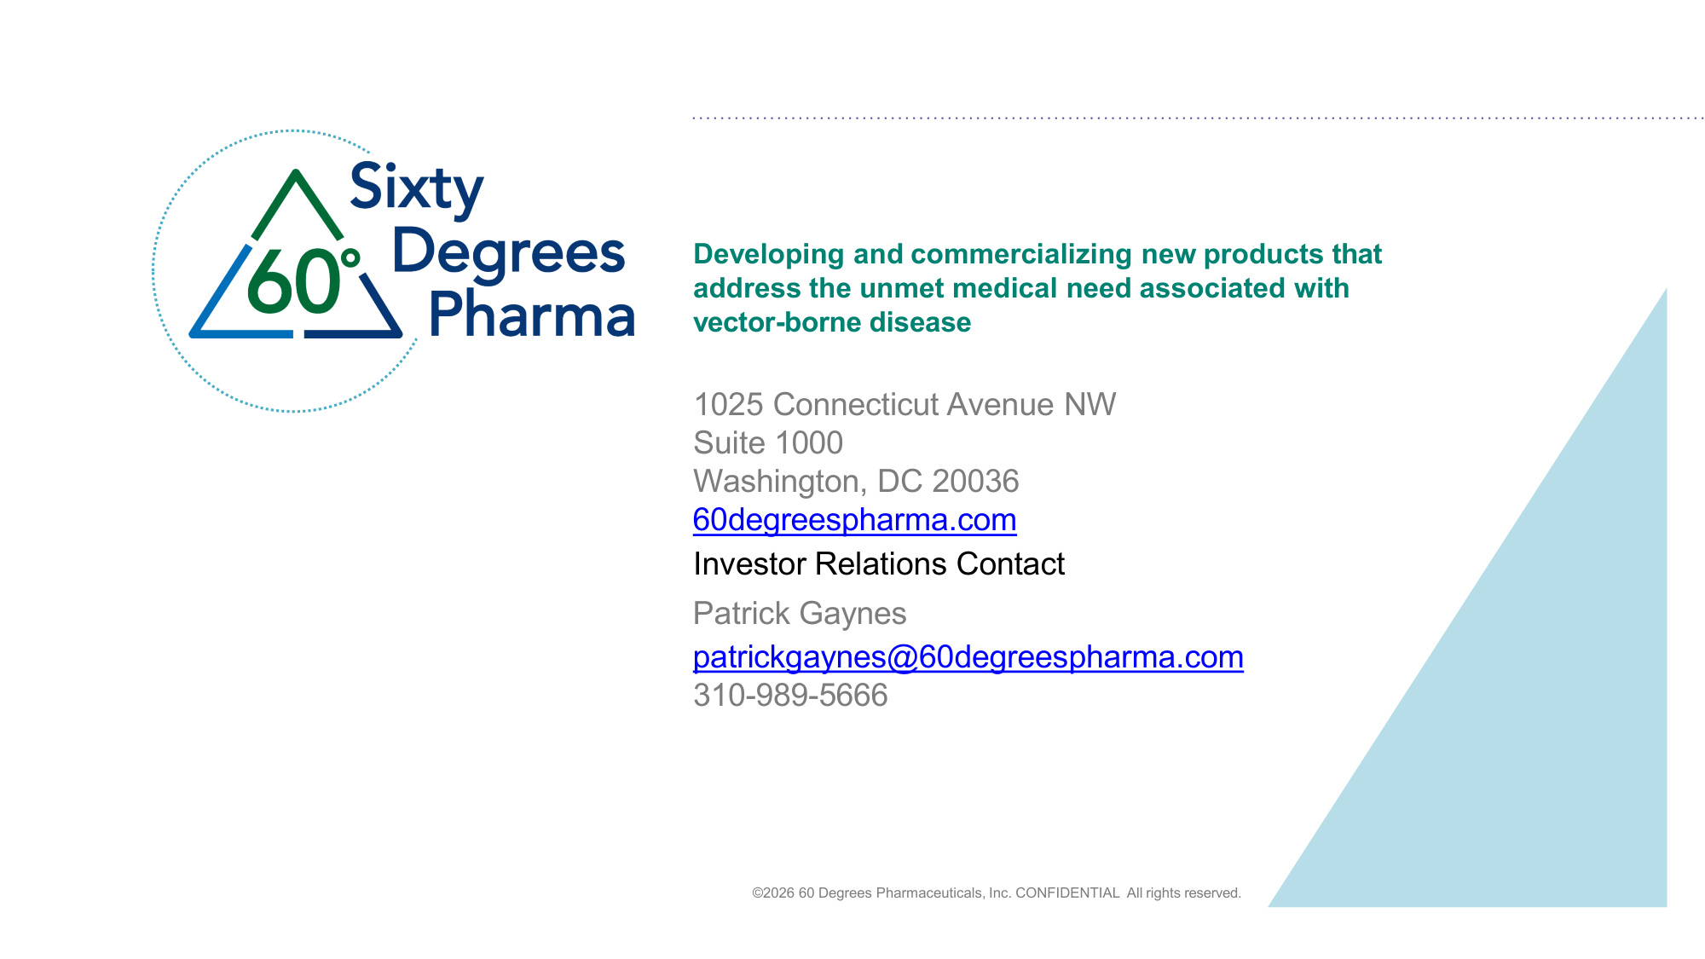
Developing and commercializing new products that address the unmet medical need associated with vector-borne disease 1025 Connecticut Avenue NW Suite 1000 Washington, DC 20036 60degreespharma.com Investor Relations Contact Patrick Gaynes patrickgaynes@60degreespharma.com 310-989-5666 ©2026 60 Degrees Pharmaceuticals, Inc. CONFIDENTIAL All rights reserved.

